|  | **MINISTRY OF EDUCATION AND TRAINING** |
| --- | --- |

| **FPT UNIVERSITY** |
| --- |
| Automatic Parking Management and Parking Fee Collection System |
| Capstone Project Document |

| **GFA22SE51** | |
| --- | --- |
| **Group Members** | Khúc Ngọc Thái (SE151055)  Tăng Chí Cường (SE150676)  Hồ Hữu Phát (SE151312)  Thuỷ Võ Anh Hoàng (SE150780)  Nguyễn Quang Dũng (SE150721) |
| **Supervisors** | Kiều Trọng Khánh  Đặng Ngọc Minh Đức |
| **Capstone Project code** | FA22SE50 |

- Ho Chi Minh, 12/2022 -

*This page is intentionally left blank*

**Table of Contents**

Acknowledgements **8**

Acronyms & Definitions **9**

I. Project Introduction **10**

1. Overview 10

1.1 Project Information 10

1.2 Project Team 10

2. Product Background 10

3. Existing Systems 11

3.1 Parking System Of Pearl Plaza 11

3.2 Aeon Tân Phú Parking System 11

3.3 Conclusion 11

4. Business Opportunity 11

5. Software Product Vision 11

6. Project Scope & Limitations 11

6.1 Major Features 11

6.2 Limitations & Exclusions 12

II. Project Management Plan **13**

1. Overview 13

1.1 Scope & Estimation 13

1.2 Project Objectives 14

1.3 Project Risks 14

2. Management Approach 15

2.1 Project Process 15

2.2 Quality Management 15

2.3 Training Plan 16

3. Project Deliverables 16

4. Responsibility Assignments 17

5. Project Communications 17

6. Configuration Management 18

6.1 Document Management 18

6.2 Source Code Management 18

6.3 Tools & Infrastructures 18

III. Software Requirements Specification **19**

1. Product Overview 19

2. User Requirements 20

2.1 Actors 20

2.2 Use Cases 20

2.2.1 Diagram 20

2.2.2 Descriptions 21

3. Functional Requirements 23

3.1 System Functional Overview 23

3.1.1 Screen flow 23

3.1.2 Screen details 25

3.1.3 Screen Authorization 27

3.1.4 Non-Screen Functions 28

3.2 Booking Progress 29

3.2.1 Booking Home 29

3.2.2 Create booking 30

3.2.2 Confirmation page 32

3.2.3 QR Scan 33

3.3 History 34

3.3.1 Booking history 34

3.3.2 Booking ticket 35

3.3.3 Parking history 36

3.3.4 Parking ticket 37

3.3.5 Done history 38

3.3.6 Done ticket 39

3.3.7 Canceled history 40

3.3.8 Canceled ticket 41

3.4 Profile 42

3.4.1 Profile information 42

3.4.2 Top-up 43

3.4.3 Transaction history 44

3.4.3 Feedback 45

3.4.4 Change password 46

3.5 Customer Authorization 48

3.5.1 Sign In 48

3.5.2 Sign Up 50

3.5.3 Forgot password 51

3.5.4 OTP Verification 52

3.6 Authorization 53

3.6.1 Login 53

3.6.2 Reset password 54

3.7 Show admin reports 55

3.8 Get car park list 56

3.9 Get ticket list 57

3.10 Get transaction history 58

3.11 Get employee list 59

3.12 Show owner reports 60

3.13 Show staff’s reports 60

3.14 Manage car park 61

4. Non-Functional Requirements 63

4.1 External Interfaces 63

4.2 Quality Attributes 63

4.2.1 Usability 63

4.2.2 Reliability 63

4.2.4 Compatibility 63

4.2.5 Security 63

5. Requirement Appendix 63

5.1 Business Rules 63

5.2 Application Messages List 65

IV. Software Design Description **66**

1. System Design 66

1.1 System Architecture 66

1.2 Package Diagram 67

1.2.1 Back-end 67

1.2.2 Front-end 68

1.2.3 Mobile 69

1.2.4 IoT 69

2. Database Design 71

3. Detailed Design 75

3.1 Check-in 75

3.1.1 Class Diagram 75

3.1.2 Sequence Diagram 76

3.2 Check-out 77

3.2.1 Class Diagram 77

3.2.2 Sequence Diagram 78

3.3 Booking 79

3.3.1 Class Diagram 79

3.3.2 Sequence Diagram 80

**V. Software Testing Documentation** **81**

1. Scope of Testing 81

2. Test Strategy 81

2.1 Testing Types & Levels 81

2.2 Supporting Tools 81

3. Test Plan 81

3.1 Human Resources 81

3.2 Test Environment 81

3.3 Test Milestones 81

4. Test Cases & Test Reports 81

VI. Release Package & User Guides 82

1. Deliverable Package 82

2. Installation Guides 82

2.1 System Requirements 82

2.2 Installation Instruction 83

2.2.1 Install camera system 83

2.2.2 Install embedded system 85

2.2.3 Install python packages 85

3. User Manual 87

3.1 Overview 87

3.2 Booking 87

3.3 Check-in 89

3.4 Check-out 90

3.5 Manual check-out 91

3.5 Update car park information 92

3.6 Create a new employee’s account 94

# Acknowledgements

We would like to express our deepest appreciation to our mentors, Mr. Kiều Trọng Khánh & Mr. Đặng Ngọc Minh Đức, for putting so much time and effort into this project.

Our gratitude to Mr. Lâm Hữu Khánh Phương, Mr. Lê Vũ Trường, Mr. Ngô Đăng Hà An and Mr. Nguyễn Thế Hoàng. Your support and suggestions are greatly appreciated.

Special thanks to Mr. Nguyễn Ngọc Quang, Mr. Nguyễn Tuấn Anh and Mr. Lương Hoàng Nhân for helping us with the project as our demonstrators, as well as providing the necessary tools and location for this project.

# Acronyms & Definitions

| **Acronym** | **Definitions** |
| --- | --- |
| Anaconda | Anaconda is a distribution of the Python and R programming languages for scientific computing (data science, machine learning applications, etc.), that aims to simplify package management and deployment. |
| API | Application Program Interface |
| APMS | Automatic Parking Management and Parking Fee Collection System |
| AWS | Amazon Web Services: A third-party service that is used to deploy front-end and back-end applications |
| BR | Business Rule: Rules and constraints to be implemented into the system |
| CUDA | CUDA programming was designed for computing with NVIDIA’s graphics processing units (GPUs). CUDA enables developers to reduce the time it takes to perform compute-intensive tasks, by allowing workloads to run on GPUs and be distributed across parallelized GPUs. |
| ERD | Entity Relationship Diagram: describes entities existing in the system and their relationships with each other |
| EX | Exclusion: Features that will not be included in the projects |
| FE | Features: Major features of the project |
| Firebase | A Backend-as-a-Service (Baas). It provides developers with a variety of tools and services to help them develop apps. It is built on Google’s infrastructure. |
| IoT | Internet of Things: is the concept of connecting any device to the Internet and to other connected devices, allow hardware to interact real time with the back-end using cloud |
| LI | Limitations of the project |
| OTP | One Time Password |
| QR | Quick Response: a type of barcode, contains data that can be scanned to retrieve |
| SHA256 | An algorithm for hashing |

# I. Project Introduction

## 1. Overview

### 1.1 Project Information

- Project name: Automatic Parking Management and Parking Fee Collection System

- Project code: APMS

- Group name: GFA22SE51

- Software type: Web, Mobile App

### 1.2 Project Team

| **Full Name** | **Role** | **Email** | **Mobile** |
| --- | --- | --- | --- |
| Kieu Trong Khanh | Mentor | khanhkt@fe.edu.vn | 0908133304 |
| Dang Ngoc Minh Duc | Mentor | ducdnm2@fpt.edu.vn | 0989699299 |
| Khuc Ngoc Thai | Leader | thaiknse151055@fpt.edu.vn | 0949936732 |
| Nguyen Quang Dung | Member | dungnqse150721@fpt.edu.vn | 0377162315 |
| Ho Huu Phat | Member | phathhse151312@fpt.edu.vn | 0932781745 |
| Thuy Vo Anh Hoang | Member | hoangtvase150780@fpt.edu.vn | 0914108001 |
| Tang Chi Cuong | Member | cuongtcse150676@fpt.edu.vn | 0908436393 |

## 2. Product Background

Nowadays, as people’s overall life quality has increased drastically compared to the past, more and more have chosen cars as their primary transportation. In many car parks, the process of parking a car requires is mostly done manually, which is extremely time-consuming. This process is also wasting so much manpower and financial resources because many functions must be completed by hand. Moreover, since most car parks in Vietnam are inadequate to support the high volume of vehicles that are using the service, drivers are tempted by the idea of booking a lot in advance to save up a huge amount of time finding a vacancy in the car park instead of having to look around to search for an available car park.

## 3. Existing Systems

### 3.1 Parking System Of Pearl Plaza

The parking system of Pearl Plaza provides visitors with the ability to take and scan RFID cards automatically, so it is not required to hire security staff at the entrance. However, visitors still have to pay the fee directly at the exit. Visitors can not book the car park in advance before coming. These are the reasons why traffic jams still occasionally happen.

### 3.2 Aeon Tân Phú Parking System

Aeon Tan Phu has an automated RFID provider at the parking gate, allowing visitors to get in more conveniently. At the exit, you can also pay the fee by using an online wallet. This method can save a lot of traffic time. However, many visitors complain that the car park is always out of service when they show up.

### 3.3 Conclusion

RFID-based parking systems are no longer an unfamiliar concept. Multinational buildings, malls, and other public areas have been applying these systems thoroughly to support their management. An automatic parking system is what we truly need, especially after social distancing in COVID times. However, the older systems (such as Pearl Plaza, Aeon Tan Phu, etc.) can not afford the best requirements. It’s essential to have a system that allows operating contactless. The combination of RFID-based system, QR, and image-processing technologies allows APMS to help customers have a better way to manage their car parking system.

## 4. Business Opportunity

Many employees have requested a system that would automate the process of parking cars and allow them to see whether the car park still has available slots or not. Such a system like this would save many customers’ time and improve overall satisfaction. It will also reduce the resources needed for running and maintaining the car park so that the company can direct those resources to other sections which could make good use of them. Also, this system should allow drivers to book a lot before they come to ensure that at the time they come, a parking space will always be available.

## 5. Software Product Vision

An automatic payout system for car park owners will be developed within one month from the first release. A plan for the addition of support for other types of vehicles such as motorcycles, bicycles, and other countries’ license plates has been considered, which should be implemented 3 months after the initial release. Extending features for human resource management are also being considered, given the fact that car park owners want to have more control over their staff.

## 6. Project Scope & Limitations

### 6.1 Major Features

FE-01: As a customer, I want to manage my transactions

FE-02: As a customer, I want to book a parking slot

FE-03: As a system administrator, I want to manage accounts that exist on the system

FE-04: As a system administrator, I want to manage car parks

FE-05: As a staff, I want to manage parking tickets

FE-06: As a staff, I want to configure car park settings

FE-07: As an owner, I want to view my car park statistics

### 6.2 Limitations & Exclusions

LI-01: The system only supports the registered users

LI-02: The current system currently only for cars and works with Vietnamese citizen license plate

LI-03: Only works with clear, visible number plates (not fully covered, heavily modified, etc.)

LI-04: The current system demands electricity and an Internet connection in order to be fully functional

EX-01: The current system does not support the individual parking slot management

EX-02: The current system does not support human resource management

EX-03: The current system does not support vehicle management, nor fake/fraud license plate detection

EX-04: The current system does not support data migration, nor integrating with other systems

# II. Project Management Plan

## 1. Overview

### 1.1 Scope & Estimation

| **#** | **WBS Item** | **Complexity** | **Est. Effort (man-days)** |
| --- | --- | --- | --- |
| ***1*** | ***Car check-in / check-out*** |  | ***112*** |
| 1.1 | Recognize the number plate of the car | Complex | 14 |
| 1.2 | Prepare dataset | Medium | 7 |
| 1.3 | Preprocess dataset | Complex | 14 |
| 1.4 | Notify user after checking in or checking out | Medium | 7 |
| 1.5 | Calculate fees | Medium | 7 |
| 1.6 | Movement detection | Complex | 14 |
| 1.7 | Generate QR code | Medium | 7 |
| 1.8 | Automate process | Complex | 14 |
| 1.9 | License plate recognition | Complex | 14 |
| 1.10 | Car recognition | Complex | 14 |
| ***2*** | ***Booking*** |  | ***33*** |
| 2.1 | Get number of available car park | Simple | 4 |
| 2.2 | Get the list of car park | Simple | 4 |
| 2.3 | Get car park detail | Simple | 4 |
| 2.4 | Create a booking | Medium | 7 |
| 2.5 | Cancel a booking | Medium | 7 |
| 2.6 | Get booking detail | Medium | 7 |
| ***3*** | ***Manage account*** |  | ***71*** |
| 3.1 | Register an account | Medium | 7 |
| 3.2 | Login | Medium | 7 |
| 3.3 | Logout | Medium | 7 |
| 3.4 | Get personal information | Simple | 4 |
| 3.5 | Update password | Simple | 4 |
| 3.6 | Top-up the money | Complex | 14 |
| 3.7 | Get history of tickets | Complex | 14 |
| 3.8 | Get ticket detail | Medium | 7 |
| 3.9 | OTP verification | Medium | 7 |
| ***6*** | ***Car park*** |  | ***46*** |
| 6.1 | View car park information | Medium | 7 |
| 6.2 | Update price table | Medium | 7 |
| 6.4 | Update car park’s information | Medium | 7 |
| 6.5 | Get parking history of specific license plate | Medium | 7 |
| 6.6 | Create new car park | Simple | 4 |
| 6.7 | Make statistics | Complex | 14 |
| ***7*** | ***Install Hardware*** |  | **61** |
| 7.1 | Config ESP32 | Medium | 7 |
| 7.2 | Connect system to firebase | Medium | 7 |
| 7.3 | Install servo | Medium | 7 |
| 7.4 | Install camera and connect to image-processing module | Complex | 20 |
| 7.5 | Setup in real environment | Complex | 20 |
| ***8*** | ***Feedback*** |  | **15** |
| 8.1 | Create feedback | Simple | 4 |
| 8.2 | Get feedback list | Medium | 7 |
| 8.3 | Get feedback detail | Simple | 4 |

***Total Estimated Effort (man-days) 338***

### 1.2 Project Objectives

| **#** | **Testing Stage** | **Test Coverage** | **No. of Defects** | **% of Defect** | **Notes** |
| --- | --- | --- | --- | --- | --- |
| 1 | System Test | >= 80% | 8 | 4% | Mostly on license plate reading |

### 1.3 Project Risks

| **#** | **Risk Description** | **Impact** | **Possibility** | **Response Plans** |
| --- | --- | --- | --- | --- |
| 1 | The team don’t have enough budget | Medium | 10 | Get a loan at the bank or find a sponsor |
| 2 | A member is sick so the tasks belong to that member cannot be done | High | 10 | Assign other members help with the tasks until the member return |
| 3 | A member is out | High | 5 | Assign members to the task belong to drop out member and work overtime |
| 4 | Deadline for the task is miscalculated | Medium | 25 | Plan and reschedule tasks to still meet time needed |

## 2. Management Approach

### 2.1 Project Process

The project process will follow the Scrum framework of the Agile methodology.

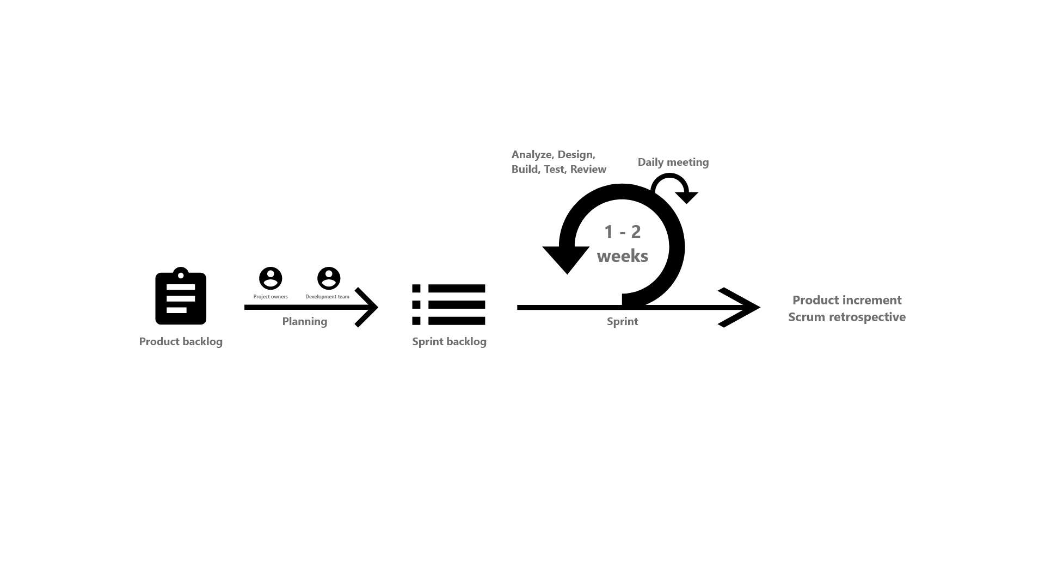

*Figure 1. Scrum process diagram (Ref:* [*scrum.org*](https://www.scrum.org/)*)*

Why we picked the Scrum framework: there are many new features that the development team is not familiar with, such as integrating number plates/cars recognizing modules, research on other car parking systems and processes, etc. If we use the waterfall method, it would be very difficult to detect errors until later in the development process, which would be costly and time-consuming to fix. Scrum framework allows us to develop the product incrementally, and divide the project into multiple sprints so that we can review the features more frequently, also we can find errors earlier in the process, making those less tricky to deal with.

### 2.2 Quality Management

- Daily meeting: a small meeting (approximately 15 mins) will be hosted every working day to resolve any problem each team member is having.

- System testing: every core function should be tested, with multiple edge cases included. 80% test coverage or higher is preferred.

- Reviewing: the development team will have a review session every week to ensure that everything is going in the right direction. For small tasks, each team member will review each other and give suggestions. In case of a big milestone, mentors will be involved.

### 

### 2.3 Training Plan

| **Training Area** | **Participants** | **When, Duration** | **Waiver Criteria** |
| --- | --- | --- | --- |
| .NET, Repository Pattern, Unit of Works Pattern | Tang Chi Cuong, Khuc Ngoc Thai | 12/9/2022 - 15/9/2022 | Mandatory |
| JIRA, Bitbucket | All members within the development team | 12/9/2022 - 13/9/2022 | Mandatory |

## 3. Project Deliverables

| **Sprint #** | **Deliverable** | **Due Date** | **Notes** |
| --- | --- | --- | --- |
| 1 | Getting requirements | 10/09/2022 | Project Management Plan, Project Introduction Document |
| 2 | Diagrams | 17/09/2022 | Context Diagram, ERD Diagram, Use Case Diagram |
| Screen flows | 17/09/2022 | For Admin, Staff and User |
| Prototypes | 17/09/2022 | Web and Mobile |
| 3 | Simple Functions for User, Admin, Staff | 24/09/2022 | Login, Logout, View and Update Profile,  Add Vehicle, Update Vehicle |
| 4 | Plate Recognition Module | 1/10/2022 |  |
| Top - up Money on Mobile | 1/10/2022 |  |
| Manage Staff for Admin | 1/10/2022 | Create, Update, View, Delete Staff |
| Manage User for Staff | 1/10/2022 | View, Delete User |
| 5 | Book parking slot on mobile | 8/10/2022 |  |
| Pay the parking fee | 8/10/2022 |  |
| Manage Booking | 8/10/2022 |  |
| Manage Parking Slot | 8/10/2022 |  |
| 6 | First Build | 15/10/2022 | Have main features but may not have authentication, authorization and validation |
| 7 | Second Build | 5/11/2022 | Complete all functions and Fix Bug |
| 8 |
| 9 |
| 10 | Third Build | 19/11/2022 | Fix Bug and Improve |
| 11 |
| 12 | Final Product | 26/11/2022 |  |
| 13 | Finalization | 3/12/2022 | Documents,User guides |
| 14 | Practice for Presentation | 10/12/2022 | Prepare Presentation Slides, Rehearsal, Final Product |
| 15 | Final Presentation |  | Complete Capstone Project |

## 4. Responsibility Assignments

| **Responsibility** | **Khuc Ngoc Thai** | **Ho Huu Phat** | **Tang Chi Cuong** | **Thuy Vo Anh Hoang** | **Nguyen Quang Dung** |
| --- | --- | --- | --- | --- | --- |
| Project Planning & Tracking | D | R | R | R | R |
| Prepare Report 1 (Project Introduction) | R | R | D | D | D |
| Prepare Report 2 (Project Management Plan) | D | D | R | R | R |
| Prepare Report 3 (Software Requirement Specification) | R | D | D | D | D |
| Prepare Report 4 (Software Design Document) | R | D | D | D | D |
| Prepare Report 5 (Software Test Document) | R | D | D | D | D |
| Prepare Report 6 (Software User Guides) | R | D | D | D | D |
| Backend related functions | D | R | D | R | R |
| Frontend related functions | R | R | R | D | D |
| Mobile related functions | S | D | S | R | R |
| IoT related functions | R | R | R | D | S |
| Image Processing related functions | S | D | R | R | R |

## 5. Project Communications

| **Communication Item** | **Who/ Target** | **Purpose** | **When, Frequency** | **Type, Tool, Method(s)** |
| --- | --- | --- | --- | --- |
| Sprint planning | All team members | Confirm tasks for the next sprint | 8:30 a.m every Sunday | Google Meet, Jira |
| Daily Scrum | All team member | Plan for the day, resolve issues | 8 a.m every working day | Google Meet, Jira |
| Sprint Retrospective | All team member | Discuss improvements for next sprint | 8 a.m every Sunday | Google Meet, Jira |

## 6. Configuration Management

### 6.1 Document Management

* Google Drive:
* [Link to document](https://drive.google.com/drive/folders/1-I7wiWaK5-fMB-TKDB7RgYHzgHlz3zhT) (permission required)
* Description: All documents and all resources needed (diagrams, images, videos, etc.) will be kept in Google Drive. Each type of document will have its folder, and the format will either be .doc, .docx, or .pdf, to keep consistency and ensure that the display of every document will be the same among different devices.
* Confluence:
* [Link to Confluence](https://apms-capstone.atlassian.net/wiki/home) (permission required)
* Description: All links leading to Google Drive will be kept here. A copy of meeting notes will also be saved here for easier access.
* Google Meet:
* [Link to Google Meet](https://meet.google.com/wgj-gfwu-qaj) (permission required)
* Description: All team meetings will be held here.

### 6.2 Source Code Management

* Bitbucket:
* [Link to source code](https://bitbucket.org/apms-capstone/workspace/projects/AP) (permission required)
* Description: Bitbucket is a Git repository management tool created by Atlassian. This can easily be integrated with Jira and Confluence to automate and keep track of every pull request made by team members. CI/CD is fully supported, which makes the deployment process much simpler.

### 6.3 Tools & Infrastructures

| **Category** | **Tools / Infrastructure** |
| --- | --- |
| **Technology** | ReactJS 18.2.0 (Front-end), Flutter 3.7.0-4.0.pre.5 (Mobile), .NET 6 (Back-end), Python 3.7.9 (Image Processing) |
| **Database** | FireBase, PostgreSQL 13.7 |
| **IDEs/Editors** | Visual Studio Code 1.71, Visual Studio 2022, Arduino CC 2.0.0 |
| **Diagramming** | Diagrams.net, Figma |
| **Documentation** | MS Word/Excel 2016, Google Docs(Reports/Documents), MS Powerpoint 2016 (Slides) |
| **Version Control** | Bitbucket(Source Codes), Google Drive/Confluence(Documents) |
| **Deployment server** | Amazon Web Service |
| **Project management** | Jira (Schedule, Tasks, Defects) |
| **Prototype** | Figma |

# III. Software Requirements Specification

## 1. Product Overview

Automatic Parking Management and Parking Fee Collection System, or APMS, is a product aimed at delivering a contactless solution by automating the process of managing public car parking lots (supermarkets, parks, etc.), thus reducing the time and human resources for the parking process. The context diagram below illustrates the external entities and system interfaces for release 1.0.

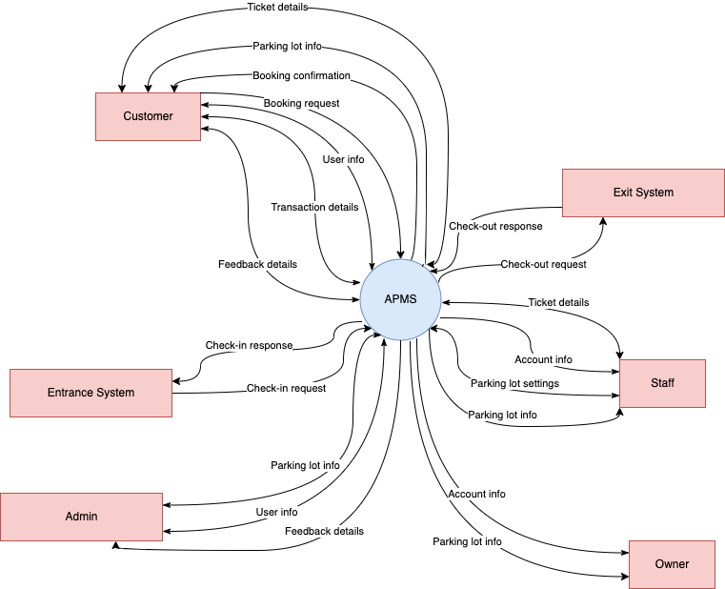

*Figure 2. Context diagram of the APMS*

## 2. User Requirements

### 2.1 Actors

| **#** | **Actor** | **Description** |
| --- | --- | --- |
| 1 | Guest | Users who are not the members of the system |
| 2 | Authenticated User | Users who are the members of the system |
| 3 | Admin | Authenticated users with the admin role, who manage all car parks and accounts in the system |
| 4 | Owner (Car Park Owner) | Authenticated users with the owner role, can make statistics their own car park |
| 5 | Staff | Authenticated users with the staff role, manage tickets, system configuration and information of their own car park |
| 6 | Customer | Authenticated users with the customer role, mostly interact with the system using the mobile application to book a parking slot and check-in at a car park |
| 7 | System Handler | Helps handle check-in/check-out processes, and automatically cancels expired tickets |

### 2.2 Use Cases

#### 2.2.1 Diagram

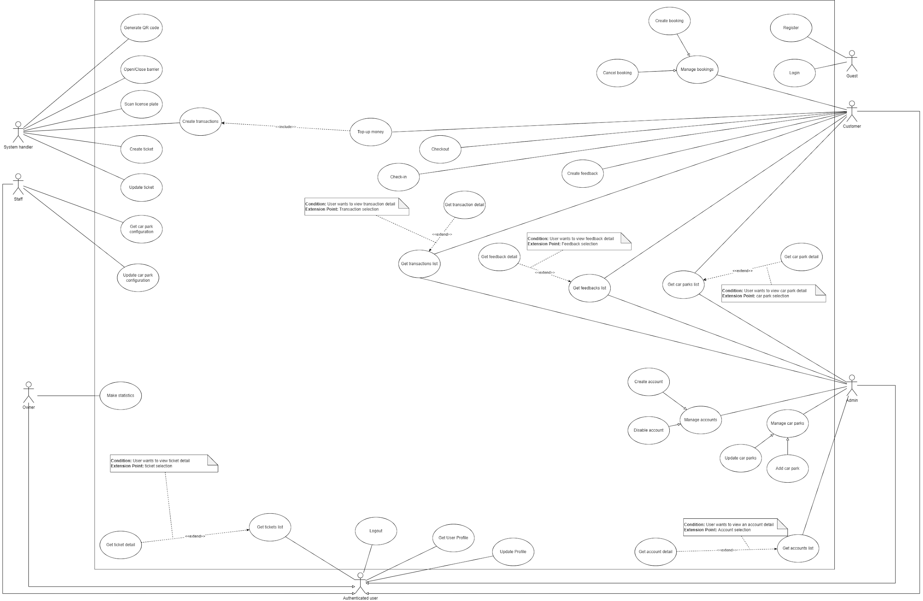

*Figure 3. Use case diagram of the APMS*

Ref: [Unified Modeling Language, v2.5.1 (omg.org)](https://www.omg.org/spec/UML/2.5.1/PDF)

Link to diagram: [Use-Case Diagram](https://drive.google.com/file/d/1k48eTCegNls9tPh4o7Vroi0qgyZ02vCQ/view)

#### 

#### 2.2.2 Descriptions

| **ID** | **Use Case** | **Actors** | **Use Case Description** |
| --- | --- | --- | --- |
| 01 | Register | Guest | User must register to use the features of the system as a customer |
| 02 | Login | Guest | Determine actor’s identity, role, and permissions |
| 03 | Get car park list | Admin, Customer | User views a list of car parks existing in the system |
| 04 | Get car park detail | Authenticated user | User views the details of a car park. Owners and staff can only view the detail of their car parks |
| 05 | Get user profile | Authenticated user | User views his own account profile |
| 06 | Update user profile | Authenticated user | User updates his own account profile |
| 07 | Get feedback list | Admin | Admin views all feedbacks. |
| 08 | Get feedback detail | Admin, Customer | User views a selected feedback detail |
| 09 | Get ticket list | Authenticated user | Admin can view all tickets. Owners and staff can only view all tickets of their car parks. Customers can only view their tickets |
| 10 | Get ticket detail | Authenticated user | User views the detail of the selected ticket |
| 11 | Make statistics | Owner | Owner makes statistics of their car park |
| 12 | Update car park configuration | Staff | Staff configures their car park settings: reservation fee, parking fee per hour, etc. |
| 13 | Top-up money | Customer | Customer can add more money to their account |
| 14 | Check-in | Customer | Customer checks in at a car park |
| 15 | Check-out | Customer | Customer checks out of a car park |
| 16 | Create feedbacks | Customer | Customer creates feedbacks to inform us about system’s issues or tell us about their experiences using the system |
| 17 | Manage bookings | Customer | Customer creates and cancels bookings |
| 18 | Create bookings | Customer | Customer creates booking for a parking slot at a specific car park |
| 19 | Cancel bookings | Customer, Staff | Customer cancels their bookings, Staff cancels bookings of their car park |
| 20 | Manage accounts | Admin | Admin can manage the accounts in the system |
| 21 | Create accounts | Admin | Admin can create accounts with Admin, Staff and Owner role |
| 22 | Deactivate accounts | Admin | Admin can deactivate accounts in the system |
| 23 | Get account list | Admin | Admin views the list of accounts in the system |
| 24 | Get account detail | Admin | Admin views the selected account detail |
| 25 | Manage car parks | Admin | Admin manages car parks in the system |
| 26 | Add car parks | Admin | Admin can add the car parks in the system |
| 27 | Update car parks | Admin | Admin can update the information of the car parks in the system |
| 28 | Remove car parks | Admin | Admin can remove car parks from the system |
| 29 | Get booking list | Authenticated user | Owner and staff can only view their car park bookings; customer can only view their bookings, and admin can view all bookings |
| 30 | Get booking detail | Authenticated user | User views the selected booking detail |
| 31 | Logout | Authenticated user | User logs out of the system |
| 32 | Create transaction | System handler | System creates a transaction when customer top up their account, book a slot or check-out at a car park |
| 33 | Create ticket | System handler | System creates a ticket ticket when customer checks in to a car park |
| 34 | Update ticket | System handler | System updates the status and total fee of the ticket when the customer checks out of a car park, or changes status of the ticket to canceled if it is expired |
| 35 | Scan license plate | System handler | System scans and recognizes license plate number when customer checks in or checks out at the car park |
| 36 | Generate QR code | System handler | System generates a QR code for customer to scan when checking in and checking out |
| 37 | Open/Close barrier | System handler | System opens or closes barriers after customer has checked in or checked out successfully |

## 

## 3. Functional Requirements

### 3.1 System Functional Overview

#### 3.1.1 Screen flow

* Customer screen flow:

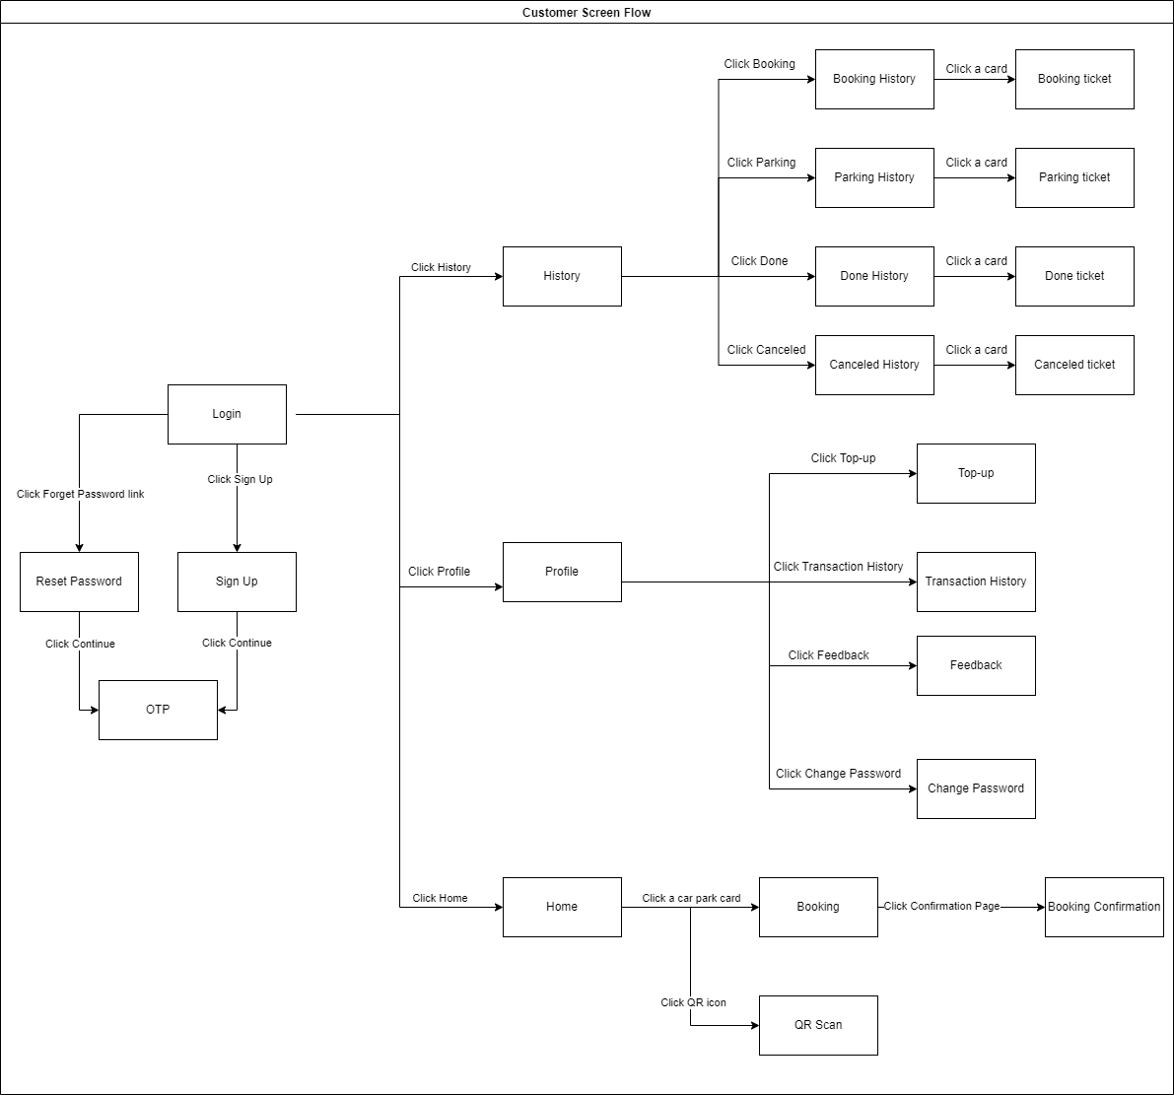

*Figure 4. Screen flow diagram for Customer mobile application*

* Admin screen flow:

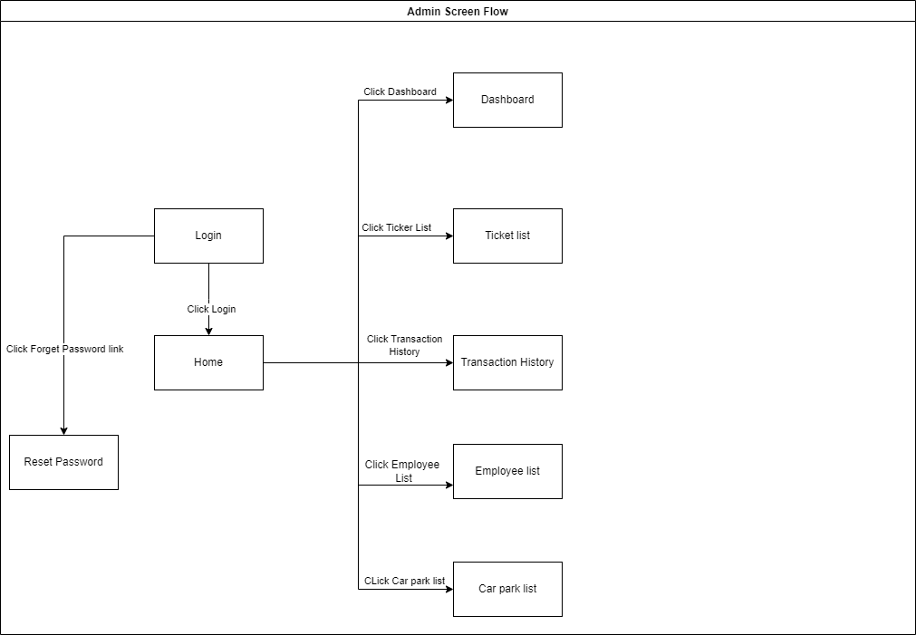

*Figure 5. Screen flow diagram for Admin web application*

* Owner screen flow:

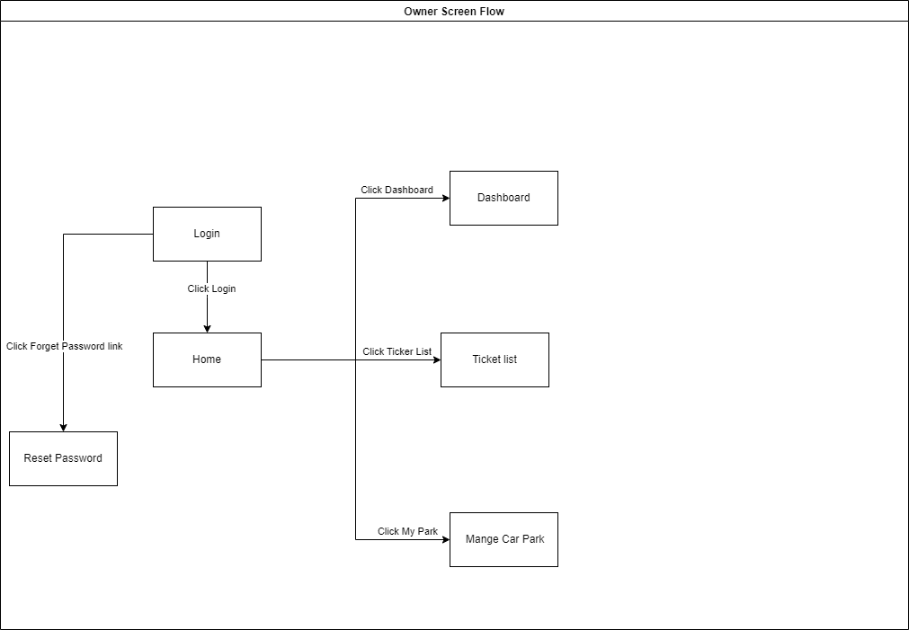

*Figure 6. Screen flow diagram for Owner web application*

* Staff screen flow:

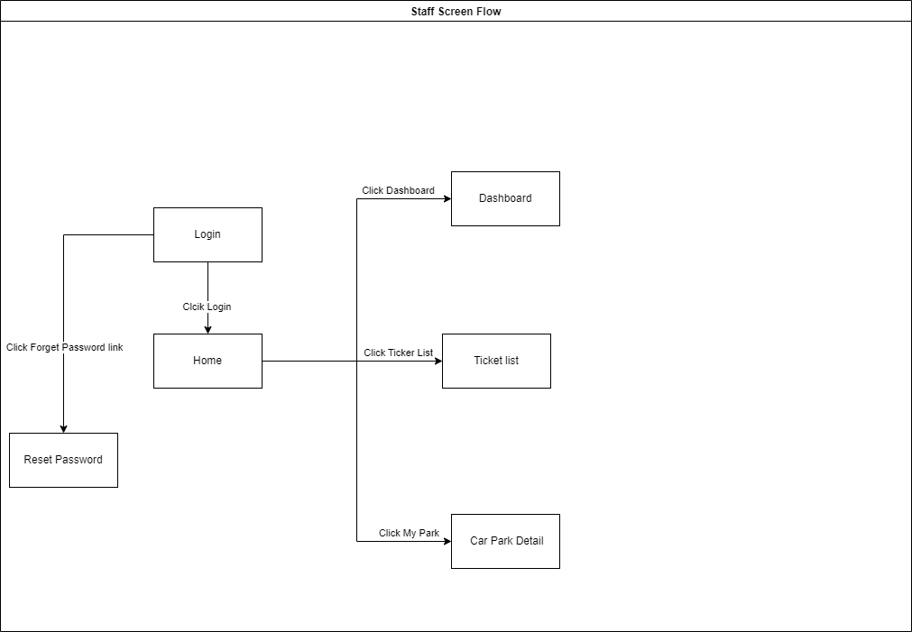

*Figure 7. Screen flow diagram for Staff web application*

#### 3.1.2 Screen details

* Customer mobile application:

##### 

| **#** | **Feature** | **Screen** | **Description** |
| --- | --- | --- | --- |
| 1 | Create account | Sign up | Display a register form for creating a customer |
| 2 | Authenticate | Sign in | Allow logging into the system using customer phone number |
| 3 | Authenticate | Forget password | Help customer retrieve their password |
| 4 | Book a slot | Home | Give user list of car parking order by distance |
| 5 | Book a slot | Create booking | Allow user to create a booking at selected car park |
| 6 | Book a slot | Booking confirmation | For customer to confirm booking detail before the system create a booking |
| 7 | Check in/out | QR Scan | Allow customer to use phone camera to scan QR code and check in or out if available |
| 8 | Get booking tickets | Booking history | Display a list of booking tickets currently in the system |
| 9 | Get booking tickets | Booking ticket | Display details of a chosen booking ticket and allow actor to cancel the ticket |
| 10 | Get parking tickets | Parking history | Display a list of parking tickets currently in the system |
| 11 | Get parking tickets | Parking ticket | Display details of a chosen booking ticket |
| 12 | Get done tickets | Done history | Display a list of done tickets in the past |
| 13 | Get done tickets | Done ticket | Display details of a chosen done ticket |
| 14 | Get canceled tickets | Canceled history | Display a list of canceled tickets in the past |
| 15 | Get canceled tickets | Canceled ticket | Display details of a chosen canceled ticket |
| 16 | Manage account | Profile | Display account’s information |
| 17 | Manage account | Change password | Allow customer to change old password |
| 18 | Top-up | Top-up | Allow customer to pay a fund he/she wants |
| 19 | Get transaction history | Transaction history | Display history of all transactions performed by customer |
| 20 | Create feedback | Send feedback | Allow customer to send a feedback |

##### 

* Admin web application:

| **#** | **Feature** | **Screen** | **Description** |
| --- | --- | --- | --- |
| 1 | Authenticate | Sign in | Allow logging into the system using customer phone number |
| 2 | Authenticate | Forget password | Help user retrieve their password |
| 3 | Get admin reports | Dashboard | Display statistics of total of users, booking, check-in; charts of system overview, employees, booking stats; list of booking details under many kinds of chart |
| 4 | Get car parks | Car park list | Display a car park list that allows user to view or edit car park details or add a new car park |
| 5 | Get tickets | Ticket list | Display ticket list that allows user to view ticket details |
| 6 | Get transaction history | Transaction history | Display a list of all transactions in the past |
| 7 | Get employees | Employee list | Display an employee list that allows user to view, edit employee details, deactivate an employee or add a new employee |

##### 

* Owner web application:

| **#** | **Feature** | **Screen** | **Description** |
| --- | --- | --- | --- |
| 1 | Authenticate | Sign in | Allow logging into the system using customer phone number |
| 2 | Authenticate | Forget password | Help user retrieve their password |
| 4 | Get tickets | Ticket list | Display ticket list that allows user to view ticket details |
| 5 | Manage car park | My park | Allow user to view or update information, fee and price of the car park and change permission of employees |

##### 

* Staff web application:

##### 

| **#** | **Feature** | **Screen** | **Description** |
| --- | --- | --- | --- |
| 1 | Authenticate | Sign in | Allow logging into the system using customer phone number |
| 2 | Authenticate | Forget password | Help user retrieve their password |
| 3 | Get staff reports | Dashboard | Display booking list of current day, scanned plate and car park overview |
| 4 | Get tickets | Ticket list | Display ticket list that allows user to view ticket details |
| 5 | Manage car park | My park | Allow user to view or update information, fee and price of the car park if he/she has permission |

##### 

#### 3.1.3 Screen Authorization

* Mobile application:

| **Screen** | **Unauthenticated User** | **Authenticated**  **User** |
| --- | --- | --- |
| Sign up | X |  |
| Sign in | X |  |
| Forget password | X |  |
| Home |  | X |
| Create booking |  | X |
| Booking confirmation |  | X |
| QR Scan |  | X |
| Booking history |  | X |
| Booking ticket |  | X |
| Parking history |  | X |
| Parking ticket |  | X |
| Done history |  | X |
| Done ticket |  | X |
| Canceled history |  | X |
| Canceled ticket |  | X |
| Profile |  | X |
| Change password |  | X |
| Top-up |  | X |
| Transaction history |  | X |
| Send feedback |  | X |

* Web application:

| **Screen** | **Unauthenticated User** | **Admin** | **Owner** | **Staff** |
| --- | --- | --- | --- | --- |
| Sign in | X |  |  |  |
| Forget password | X |  |  |  |
| Admin dashboard |  | X |  |  |
| Owner dashboard |  |  | X |  |
| Staff dashboard |  |  |  | X |
| Car park list |  | X |  |  |
| Ticket list |  |  | X | X |
| Transaction history |  | X |  |  |
| Employee list |  | X |  |  |
| My park |  | X |  |  |

#### 3.1.4 Non-Screen Functions

| **#** | **Feature** | **System Function** | **Description** |
| --- | --- | --- | --- |
| 1 | Security | Password Hashing | All passwords are hashed with salt using SHA256 |
| 2 | Booking management | Automatically cancel bookings | Automatically cancel bookings that are expired |
| 3 | Image processing | Detect vehicle and its number plate | Recognize plate number from pictures |

### 

### 

### 3.2 Booking Progress

#### 3.2.1 Booking Home

* + - **Function trigger:** Actor goes to the home screen after logging in or clicks “Home” button in the bottom menu
    - **Function description:** Actor can search for nearest car park here
    - **Screen Layout:**

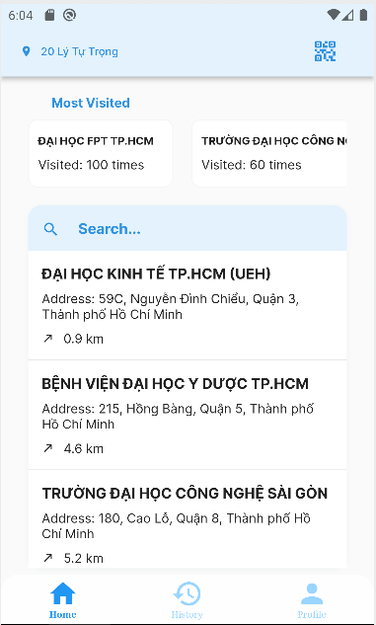

*Figure 8. Home screen*

* + - **Function details:**

Fields:

| **#** | **Field name** | **Description** | **Read only** | **Mandatory** | **Control type** | **Data type** |
| --- | --- | --- | --- | --- | --- | --- |
| 1 | Car park search | Fill car park information | No | Yes | Text box | String |

Buttons/Links:

| **#** | **Function** | **Description** | **Validation** | **Outcome** |
| --- | --- | --- | --- | --- |
| 2 | QR Scan | Click to open camera and scan QR | No | Proceed to QR scan screen |
| 3 | Home | Click to go to home | No | Switch to home screen |
| 4 | History | Click to view ticket history | No | Switch to ticket history screen |
| 5 | Profile | Click to view profile information | No | Switch to profile screen |

#### 

#### 3.2.2 Create booking

* + - **Function trigger:** Actor clicks on a car park card in the middle of the screen
    - **Function description:** Actor can book a ticket
    - **Screen Layout:**

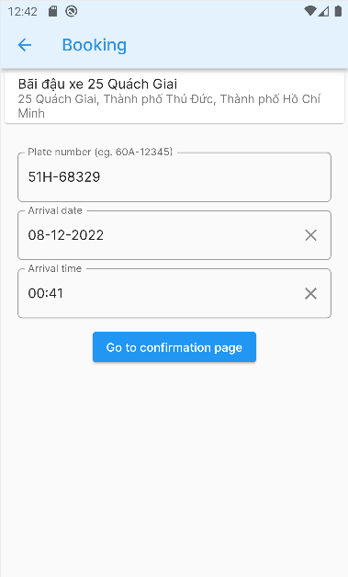

*Figure 9. Create Booking screen*

* + - **Function details:**

Fields:

| **#** | **Field name** | **Description** | **Read only** | **Mandatory** | **Control type** | **Data type** |
| --- | --- | --- | --- | --- | --- | --- |
| 1 | Plate number | Fill car’s plate number | No | Yes | Text box | String |
| 2 | Arrival date | Fill arrival date | No | Yes | Text box/Date | Date |
| 3 | Arrival time | Fill arrival time | No | Yes | Text box/Time | Time |

Buttons/Links:

| **#** | **Function** | **Description** | **Validation** | **Outcome** |
| --- | --- | --- | --- | --- |
| 4 | Go to confirmation page | Click to confirm inputted booking details | Yes | Proceed to confirmation page |

#### 3.2.2 Confirmation page

* + - **Function trigger:** Actor clicks on “Go to confirmation page” button
    - **Function description:** Actor gets booking confirmation
    - **Screen Layout:**

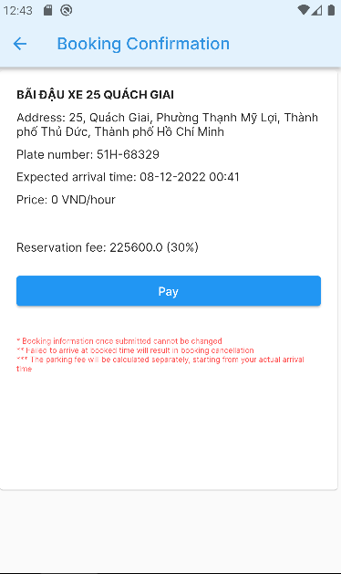

*Figure 10. Booking Confirmation screen*

* + - **Function details:**

Buttons/Links:

| **#** | **Function** | **Description** | **Validation** | **Outcome** |
| --- | --- | --- | --- | --- |
| 1 | Pay | Click to pay reservation fee | Yes | Proceed to pay reservation fee |

#### 3.2.3 QR Scan

* + - **Function trigger:** Actor clicks on “QR Scan” button on the top right of home screen
    - **Function description:** Actor scans QR to check in or check out
    - **Screen Layout:**

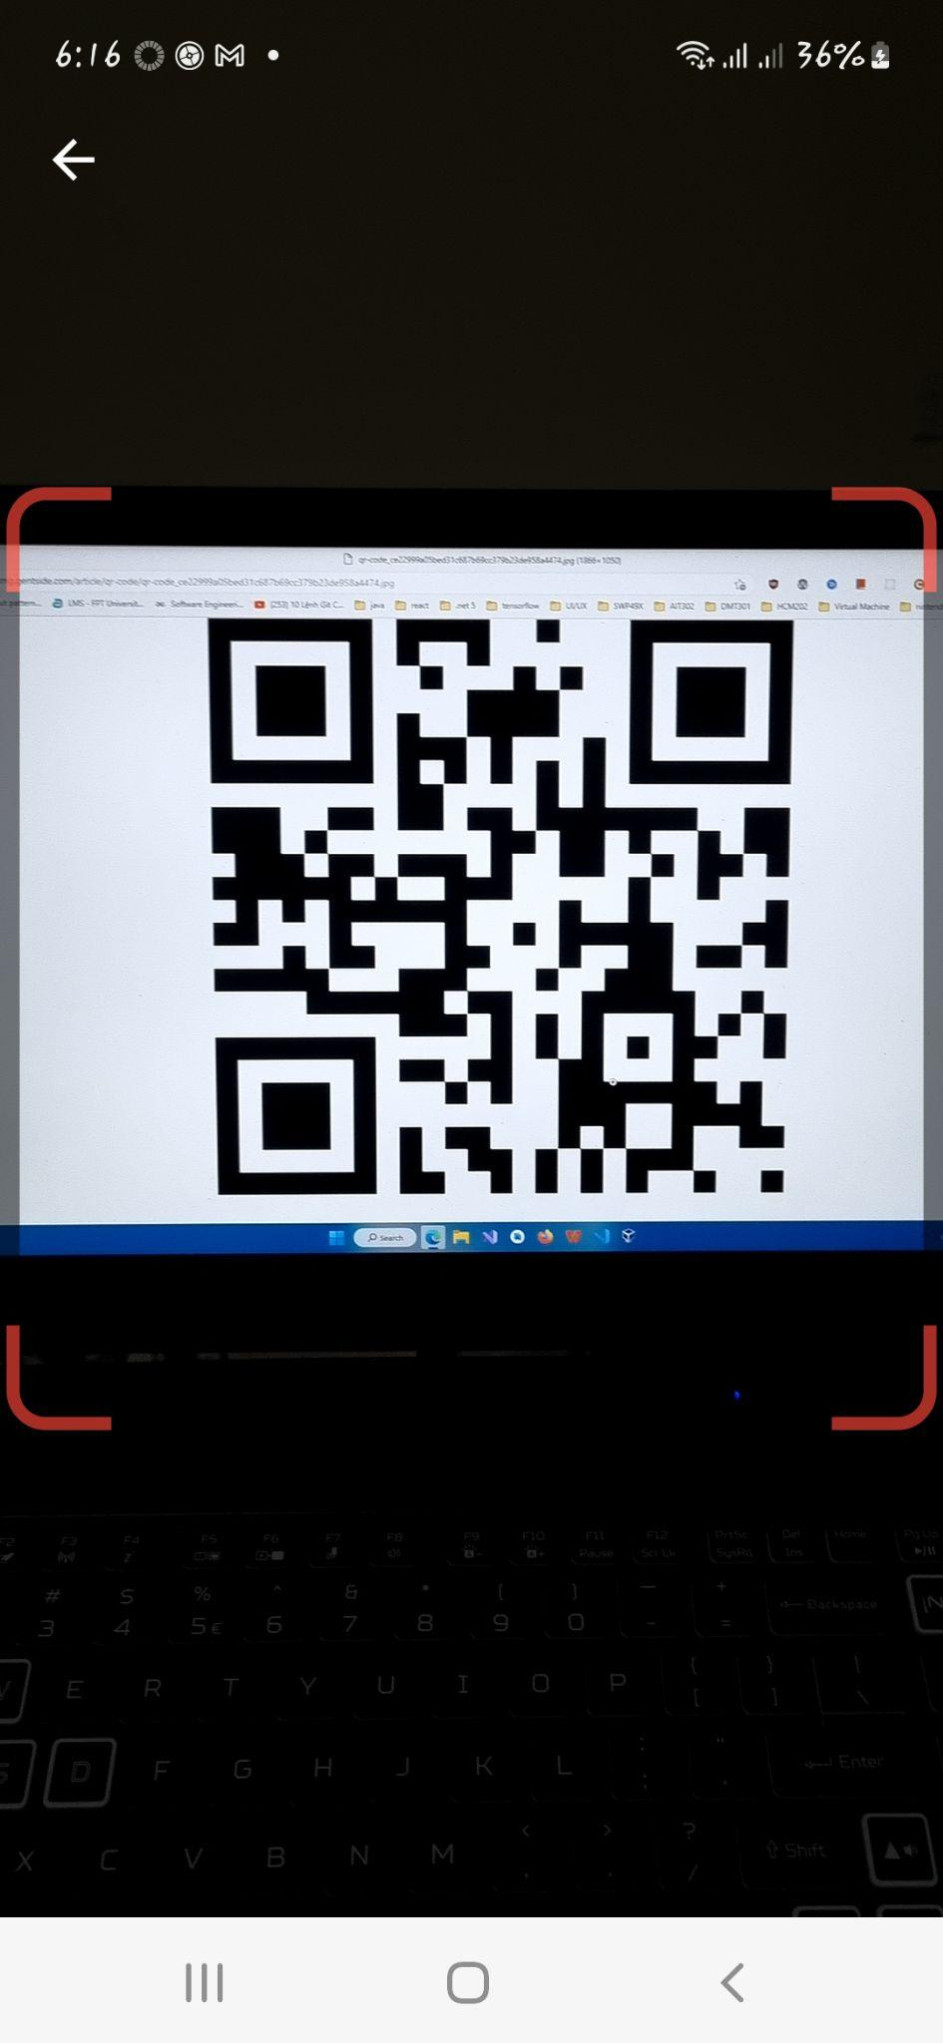

*Figure 11. QR Scan screen*

* + - **Function details:**

Buttons/Links:

| **#** | **Function** | **Description** | **Validation** | **Outcome** |
| --- | --- | --- | --- | --- |
| 1 | Pay | Click to pay reservation fee | Yes | Proceed to pay reservation fee |

### 3.3 History

#### 3.3.1 Booking history

* + - **Function trigger:** Click “Booking” in the top menu
    - **Function description:** Actor can view booking history
    - **Screen Layout:**

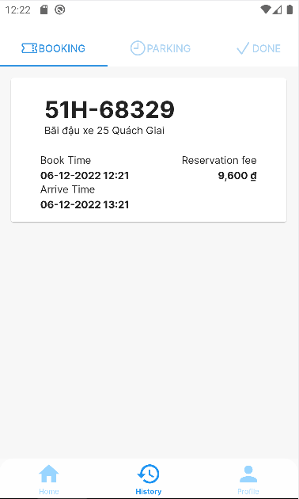

*Figure 12. Booking History screen*

* + - **Function details:**

Buttons/Links:

| **#** | **Function** | **Description** | **Validation** | **Outcome** |
| --- | --- | --- | --- | --- |
| 1 | Booking ticket card | Click on a card to view the booking ticket detail | No | Proceed to booking ticket |

#### 

#### 

#### 3.3.2 Booking ticket

* + - **Function trigger:** Click on a card to view booking ticket
    - **Function description:** Actor can view booking ticket detail or cancel booking
    - **Screen Layout:**

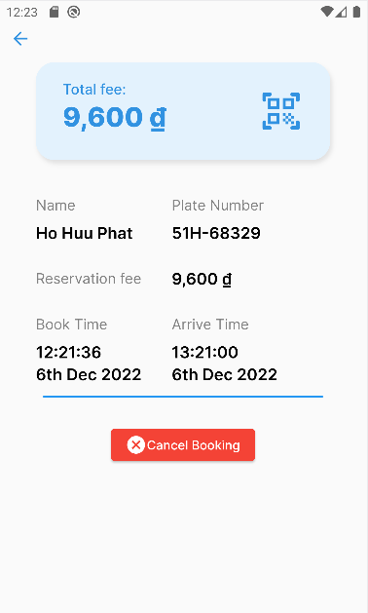

*Figure 13. Booking Ticket screen*

* + - **Function details:**

Buttons/Links:

| **#** | **Function** | **Description** | **Validation** | **Outcome** |
| --- | --- | --- | --- | --- |
| 1 | Cancel Booking | Click to cancel booking | No | Proceed to QR scan screen |

#### 

#### 3.3.3 Parking history

* + - **Function trigger:** Click “Parking” in the top menu
    - **Function description:** Actor can view parking ticket detail
    - **Screen Layout:**

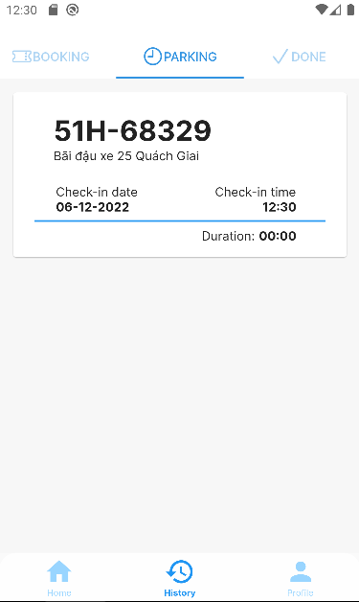

*Figure 14. Parking History screen*

* + - **Function details:**

Buttons/Links:

| **#** | **Function** | **Description** | **Validation** | **Outcome** |
| --- | --- | --- | --- | --- |
| 1 | Parking ticket card | Click on a card to view the parking ticket detail | No | Proceed to parking ticket |

#### 

#### 

#### 3.3.4 Parking ticket

* + - **Function trigger:** Click on a card to view parking ticket
    - **Function description:** Actor can view parking ticket history
    - **Screen Layout:**

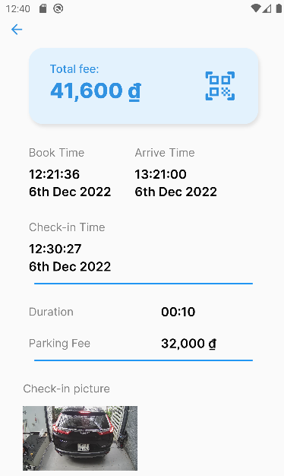

*Figure 15. Parking Ticket screen*

#### 

#### 

#### 3.3.5 Done history

#### 

* + - **Function trigger:** Click “Done” in the top menu
    - **Function description:** Actor can view done history
    - **Screen Layout:**

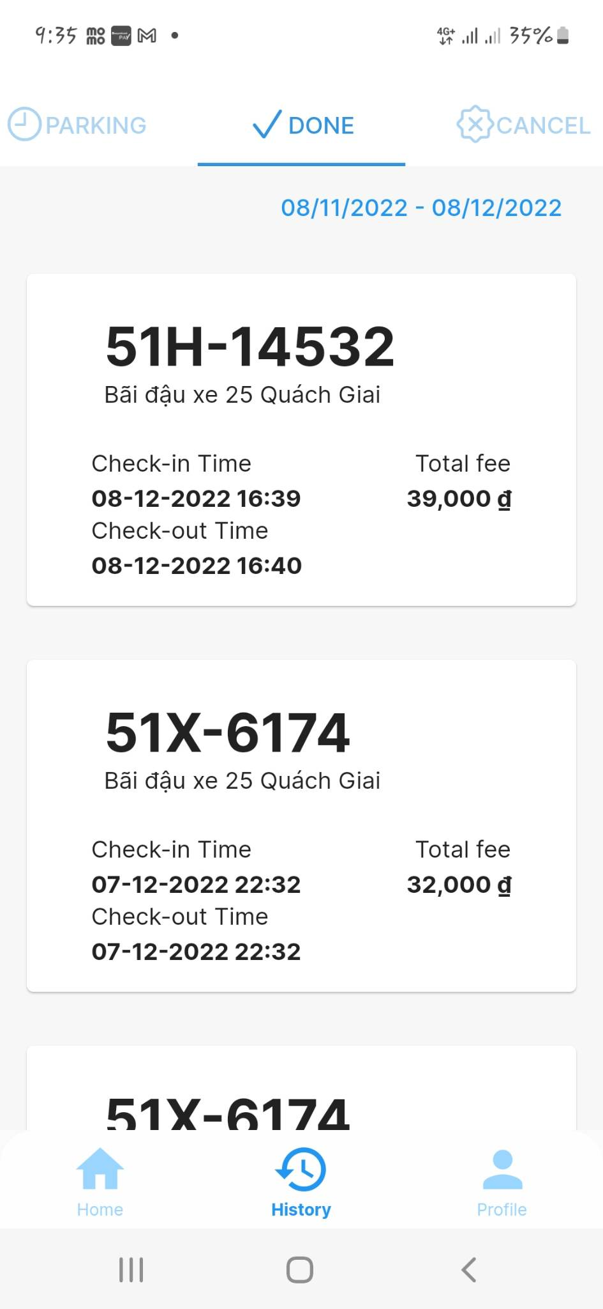

*Figure 16. Done History screen*

* + - **Function details:**

Buttons/Links:

| **#** | **Function** | **Description** | **Validation** | **Outcome** |
| --- | --- | --- | --- | --- |
| 1 | Done ticket card | Click on a card to view the done ticket detail | No | Proceed to done ticket |

#### 

#### 3.3.6 Done ticket

* + - **Function trigger:** Click on a card to view done ticket
    - **Function description:** Actor can view done ticket detail
    - **Screen Layout:**

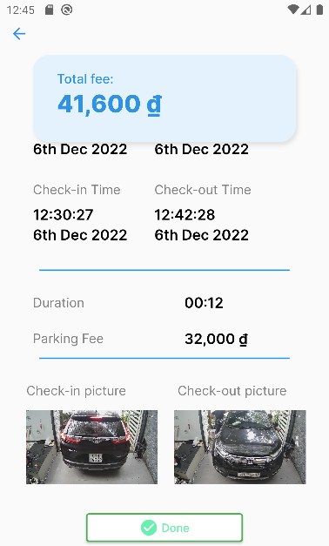‘

*Figure 17. Done Ticket screen*

#### 3.3.7 Canceled history

* + - **Function trigger:** Click “Canceled” in the top menu
    - **Function description:** Actor can view history of booking that has been canceled
    - **Screen Layout:**

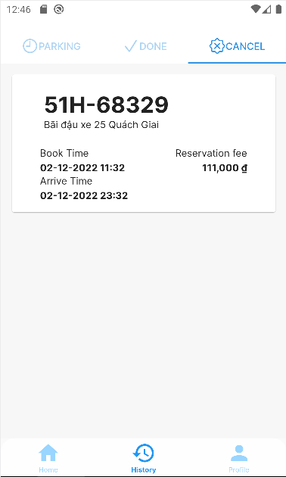

*Figure 18. Canceled History screen*

* + - **Function details:**

Buttons/Links:

| **#** | **Function** | **Description** | **Validation** | **Outcome** |
| --- | --- | --- | --- | --- |
| 1 | Canceled ticket card | Click on a card to view the canceled ticket detail | No | Proceed to canceled ticket |

#### 

#### 

#### 3.3.8 Canceled ticket

* + - **Function trigger:** Click on a card to view canceled ticket
    - **Function description:** Actor can view canceled ne ticket detail
    - **Screen Layout:**

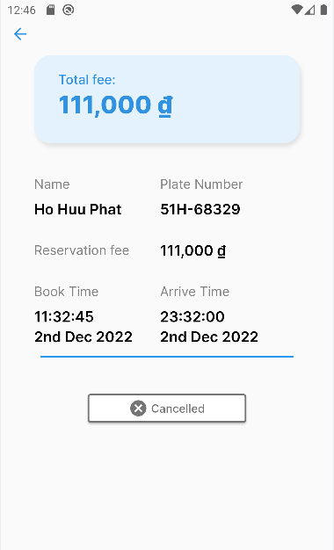‘

*Figure 19. Canceled Ticket screen*

### 

### 

### 3.4 Profile

#### 3.4.1 Profile information

* + - **Function trigger:** Actor clicks “Profile” button in the bottom menu
    - **Function description:** Actor can view or update account balance, view transaction history, send feedback, change password and log out
    - **Screen Layout:**

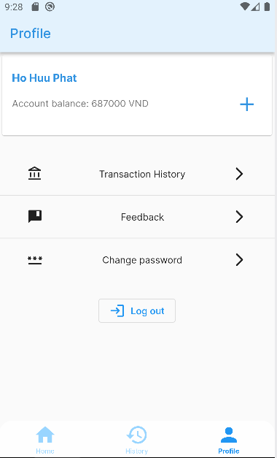

*Figure 20. Profile screen*

* + - **Function details:**

Buttons/Links:

| **#** | **Function** | **Description** | **Validation** | **Outcome** |
| --- | --- | --- | --- | --- |
| 1 | Topup | Click to add funds | No | Proceed to top-up screen |
| 2 | Transaction history | Click to view recent transaction | No | Proceed to transaction history screen |
| 4 | Feedback | Click to send a feedback | No | Proceed to feedback screen |
| 5 | Change password | Click to change current password | No | Proceed to change password screen |
| 6 | Log out | Click to log out | No | Log current account out |

#### 3.4.2 Top-up

* + - **Function trigger:** Actor clicks “Top-up” button on the right side of account balance
    - **Function description:** Actor can choose a fund to add
    - **Screen Layout:**

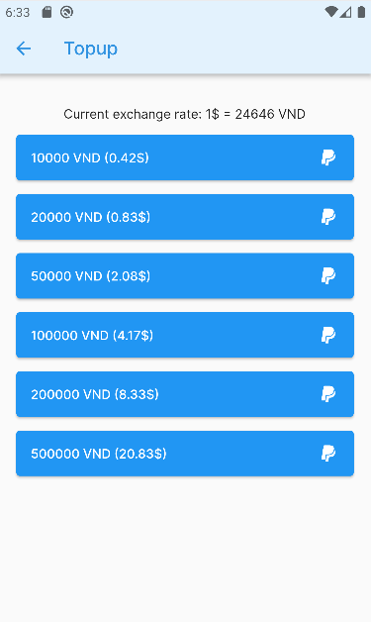

*Figure 21. Top-up screen*

* + - **Function details:**

Buttons/Links:

| **#** | **Function** | **Description** | **Validation** | **Outcome** |
| --- | --- | --- | --- | --- |
| 1 | Fund | Click to choose a fund you want to add | No | Proceed to Paypal |

#### 

#### 3.4.3 Transaction history

* + - **Function trigger:** Actor clicks “Transaction” button in the middle of profile
    - **Function description:** Actor can view transaction history
    - **Screen Layout:**

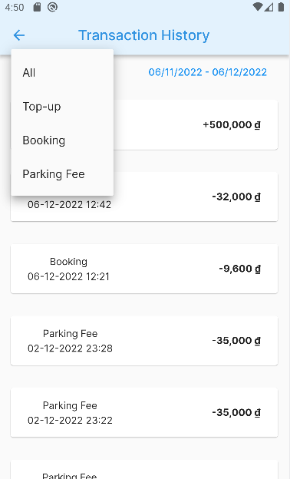

*Figure 22. Transaction History screen*

* + - **Function details:**

Fields:

| **#** | **Field name** | **Description** | **Read only** | **Mandatory** | **Control type** | **Data type** |
| --- | --- | --- | --- | --- | --- | --- |
| 1 | Transaction type | Filter transaction list | No | No | Dropdown List | List |

#### 3.4.3 Feedback

* + - **Function trigger:** Actor clicks “Feedback” button in the middle of profile
    - **Function description:** Actor can send a feedback
    - **Screen Layout:**

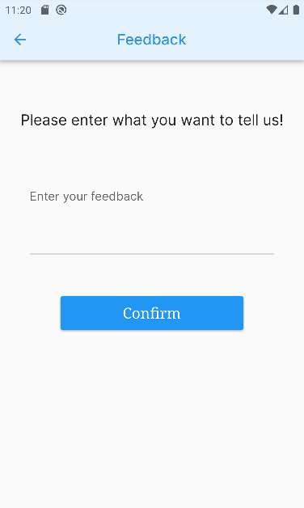

*Figure 23. Feedback screen*

* + - **Function details:**

Fields:

| **#** | **Field name** | **Description** | **Read only** | **Mandatory** | **Control type** | **Data type** |
| --- | --- | --- | --- | --- | --- | --- |
| 1 | Enter feedback | Fill feedback detail | No | Yes | Text box | String |

Buttons/Links:

| **#** | **Function** | **Description** | **Validation** | **Outcome** |
| --- | --- | --- | --- | --- |
| 2 | Confirm | Click to confirm sending feedback | Yes | Send inputted feedback |

#### 3.4.4 Change password

* + - **Function trigger:** Actor clicks “Change Password” button in the middle of profile
    - **Function description:** Actor can change current password
    - **Screen Layout:**

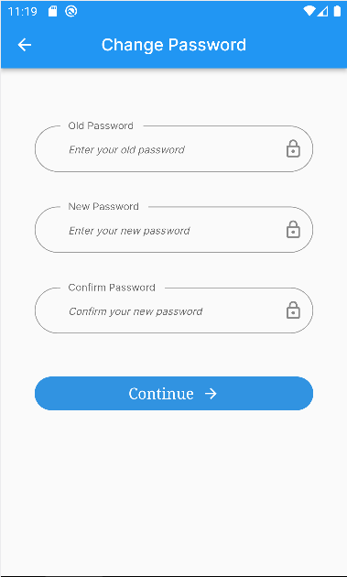

*Figure 24. Change Password screen*

* + - **Function details:**

Fields:

| **#** | **Field name** | **Description** | **Read only** | **Mandatory** | **Control type** | **Data type** |
| --- | --- | --- | --- | --- | --- | --- |
| 1 | Enter old password | Fill old password | No | Yes | Password | String |
| 2 | Enter new password | Fill new password | No | Yes | Password | String |
| 3 | Confirm new password | Re-enter new password | No | Yes | Password | String |

Buttons/Links:

| **#** | **Function** | **Description** | **Validation** | **Outcome** |
| --- | --- | --- | --- | --- |
| 4 | Continue | Click to keep changing password | Yes | Back to profile screen |

### 

### 3.5 Customer Authorization

#### 3.5.1 Sign In

● **Function trigger:** Actor goes to Sign In screen

● **Function description:** Actor fill out a sign-in form and submit to sign in account

● **Screen layout:**

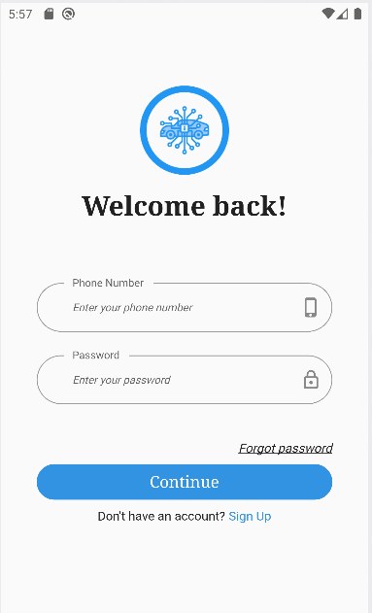

*Figure 25. Sign In screen*

* + - **Function details**:

Fields:

| **#** | **Field name** | **Description** | **Read only** | **Mandatory** | **Control type** | **Data type** |
| --- | --- | --- | --- | --- | --- | --- |
| 1 | Phone number | Fill Phone number | No | Yes | Text box | Number |
| 2 | Password | Fill Password | No | Yes | Password | String |

Buttons/Links:

| **#** | **Function** | **Description** | **Validation** | **Outcome** |
| --- | --- | --- | --- | --- |
| 3 | Continue | Click to continue signing in | Yes | Proceed to homepage |
| 4 | Forgot password | Click to reset password | No | Proceed to reset password view |
| 5 | Sign Up | Click to sign up a new customer account | No | Proceed to sign-up screen |

○ The Actor will successfully log in to the system when the phone number is available in the system and the password is matched.

○ When Actor unsuccessfully logs in to the system, error messages will be displayed under the fields.

#### 

#### 3.5.2 Sign Up

* + - **Function trigger:** The actor clicks on the “Sign Up” button under the “Login” button
    - **Function description:** The actor fills out a sign-in form and submits to sign up a new account with inputted details
    - **Screen Layout:**

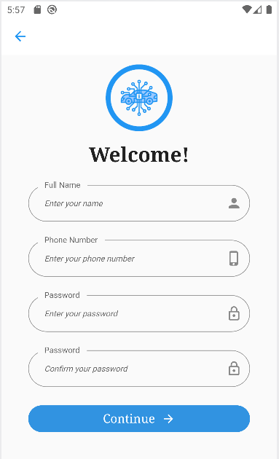

*Figure 26. Sign Up screen*

* + - **Function details:**

Fields:

| **#** | **Field name** | **Description** | **Read-only** | **Mandatory** | **Control type** | **Data type** |
| --- | --- | --- | --- | --- | --- | --- |
| 1 | Full name | Fill full name | No | Yes | Text box | String |
| 2 | Phone number | Fill phone number | No | Yes | Text box | Number |
| 3 | Password | Fill password | No | Yes | Password | String |
| 4 | Confirm password | Re-enter above password | No | Yes | Password | String |

Buttons/Links:

| **#** | **Function** | **Description** | **Validation** | **Outcome** |
| --- | --- | --- | --- | --- |
| 5 | Continue | Click to sign up account | Yes | Proceed to Sign In screen |

#### 3.5.3 Forgot password

* + - **Function trigger:** Actor clicks on the “Forgot Password” link
    - **Function description:** Actor enters phone number and receive OTP message
    - **Screen Layout:**

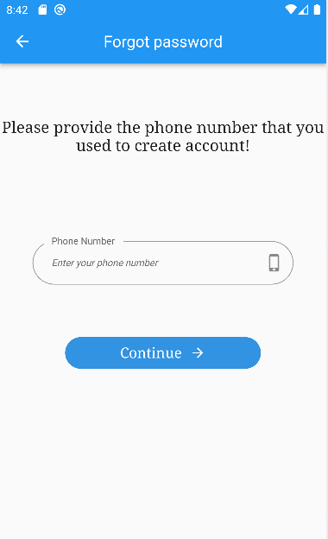

*Figure 27. Forget Password screen*

* + - **Function details:**

Fields:

| **#** | **Field name** | **Description** | **Read-only** | **Mandatory** | **Control type** | **Data type** |
| --- | --- | --- | --- | --- | --- | --- |
| 1 | Phone number | Fill phone number | No | Yes | Text box | Number |

Buttons/Links:

| **#** | **Function** | **Description** | **Validation** | **Outcome** |
| --- | --- | --- | --- | --- |
| 2 | Continue | Click to confirm phone number | Yes | Proceed to OTP confirmation screen |

#### 3.5.4 OTP Verification

* + - **Function trigger:** Actor clicks on the “Forgot password” button above the “Continue” button
    - **Function description:** System will send an OTP message to the Actor’s phone number for resetting password or signing up
    - **Screen Layout:**

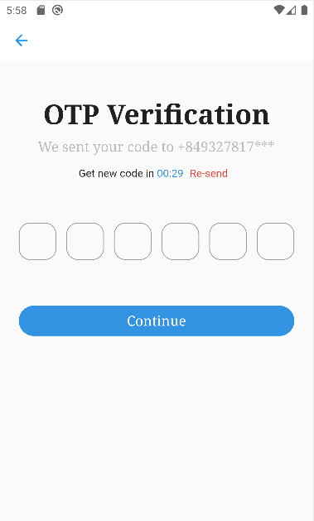

*Figure 28. OTP Confirmation screen*

* + - **Function details:**

○ The system will check if the phone number exists in the system or not.

○ If the phone number exists, the system will send an email containing a reset password OTP message to the inputted phone number.

○ If the phone number does not exist, an error message will be displayed under the incorrect field.

○ After clicking the reset password link, the Actor is required to input a new password for their account.

### 3.6 Authorization

#### 3.6.1 Login

● **Function trigger:** Actor tries to access the <http://apms.ga> website

● **Function description:** Actor fills out a login form and submits to login account

● **Screen layout:**

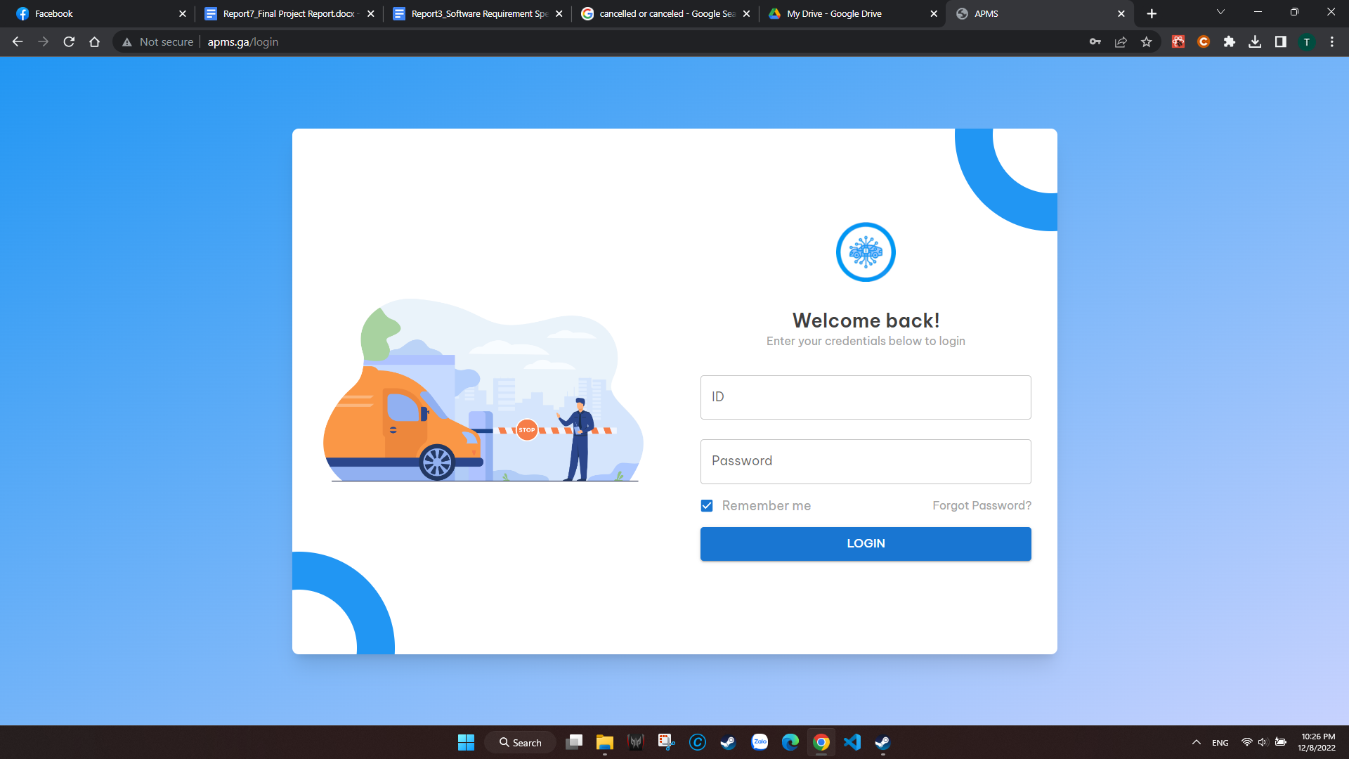

*Figure 29. Login screen*

* **Function details**:

Fields:

| **#** | **Field name** | **Description** | **Read only** | **Mandatory** | **Control type** | **Data type** |
| --- | --- | --- | --- | --- | --- | --- |
| 1 | ID | Fill account ID | No | Yes | Text box | String |
| 2 | Password | Fill Password | No | Yes | Password | String |

Buttons/Links:

| **#** | **Function** | **Description** | **Validation** | **Outcome** |
| --- | --- | --- | --- | --- |
| 3 | Login | Click to login account | Yes | Proceed to homepage |
| 4 | Forgot password | Click to reset password | No | Proceed to reset password view |

○ The Actor will successfully log in to the system when their phone number and password are correct.

○ When Actor unsuccessfully logs in to the system, error messages will be displayed under the fields.

#### 3.6.2 Reset password

* + - **Function trigger:** Actor clicks on the “Forgot password” button above the “Login” button
    - **Function description:** System will send a Reset Password OTP message to the Actor’s phone number so that the actor can reset his password
    - **Screen Layout:**

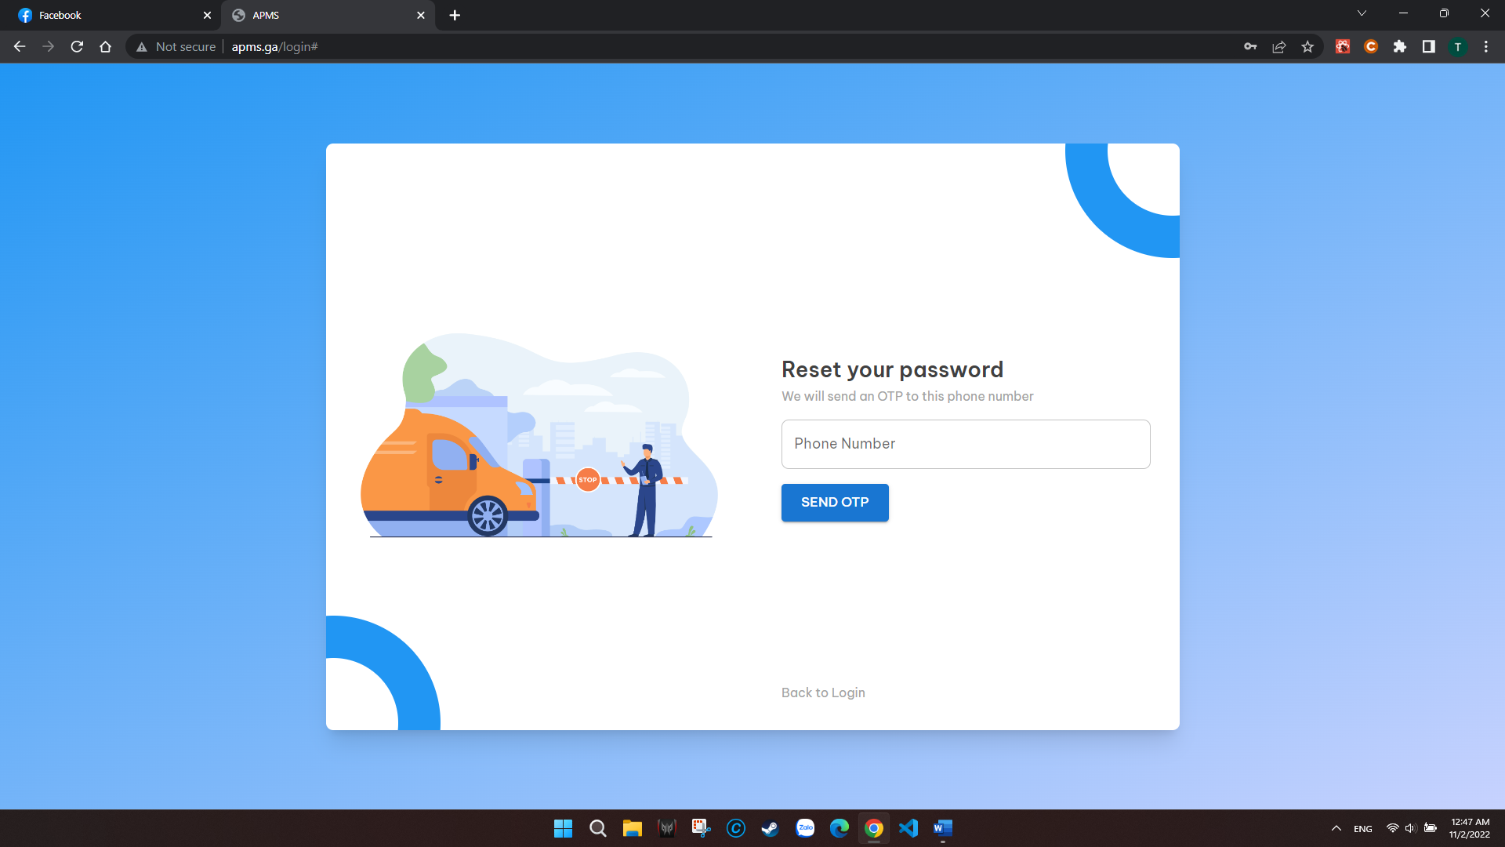

*Figure 30. Reset Password screen*

* + - **Function details:**

○ The system will check if the phone number exists in the system or not.

○ If the phone number exists, the system will send an email containing a reset password OTP message to the inputted phone number.

○ If the phone number does not exist, an error message will be displayed under the incorrect field.

○ After clicking the reset password link, the Actor is required to input a new password for their account.

### 3.7 Show admin reports

* + - **Function trigger:** Click on “Dashboard” on the left menu
    - **Function description:** System displays total of users, booking, check-in; charts of system overview, employees, booking stats; list of booking details
    - **Screen Layout:**

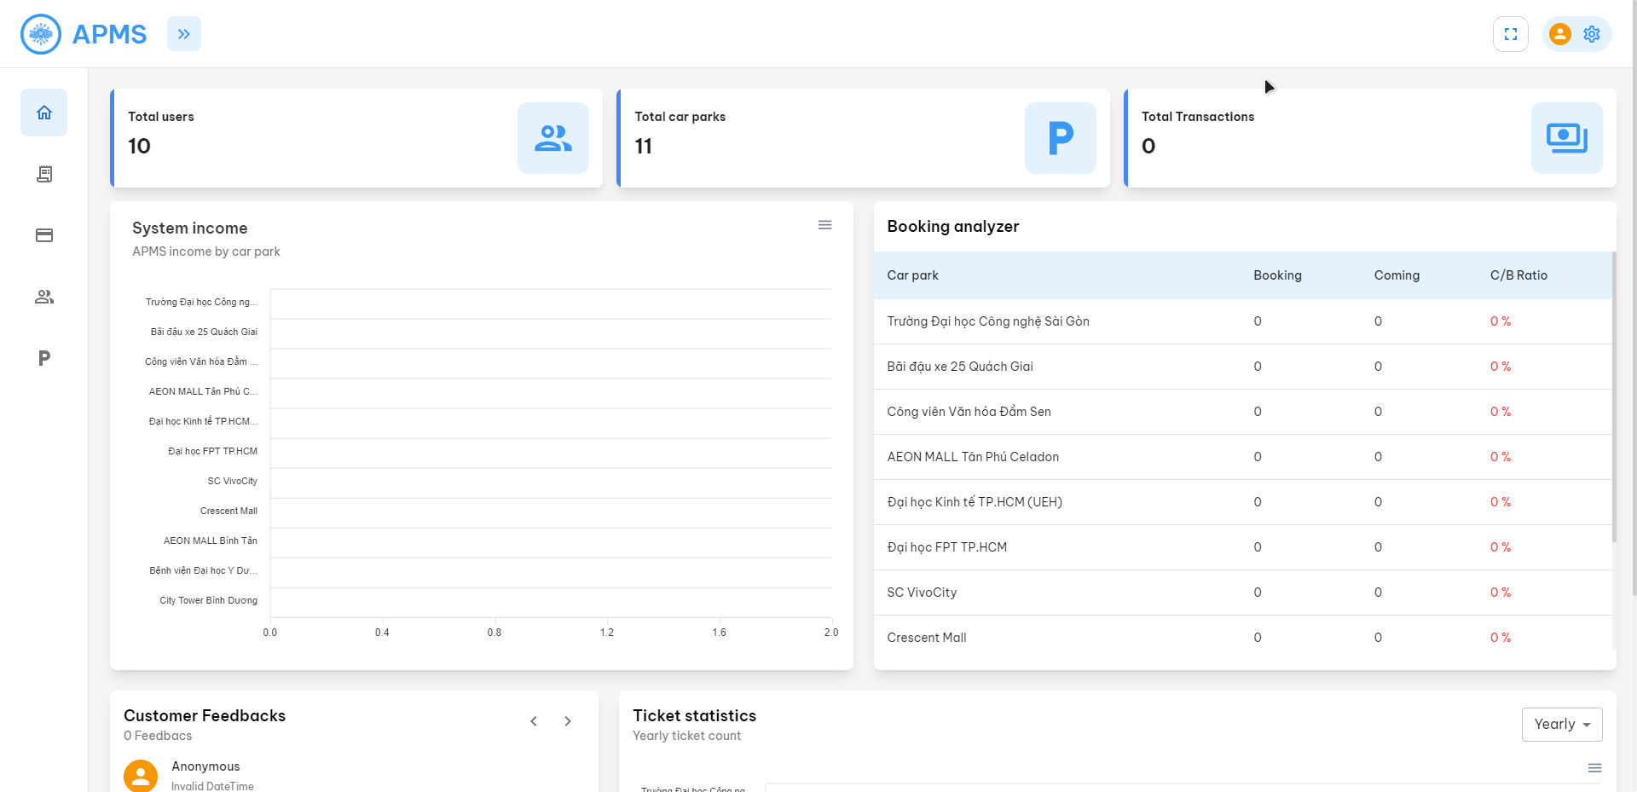

*Figure 31. Admin Dashboard screen*

### 

### 3.8 Get car park list

* + - **Function trigger:** Click on “Car parks” on the left menu
    - **Function description:** System displays a list of car parks currently in the system
    - **Screen Layout:**

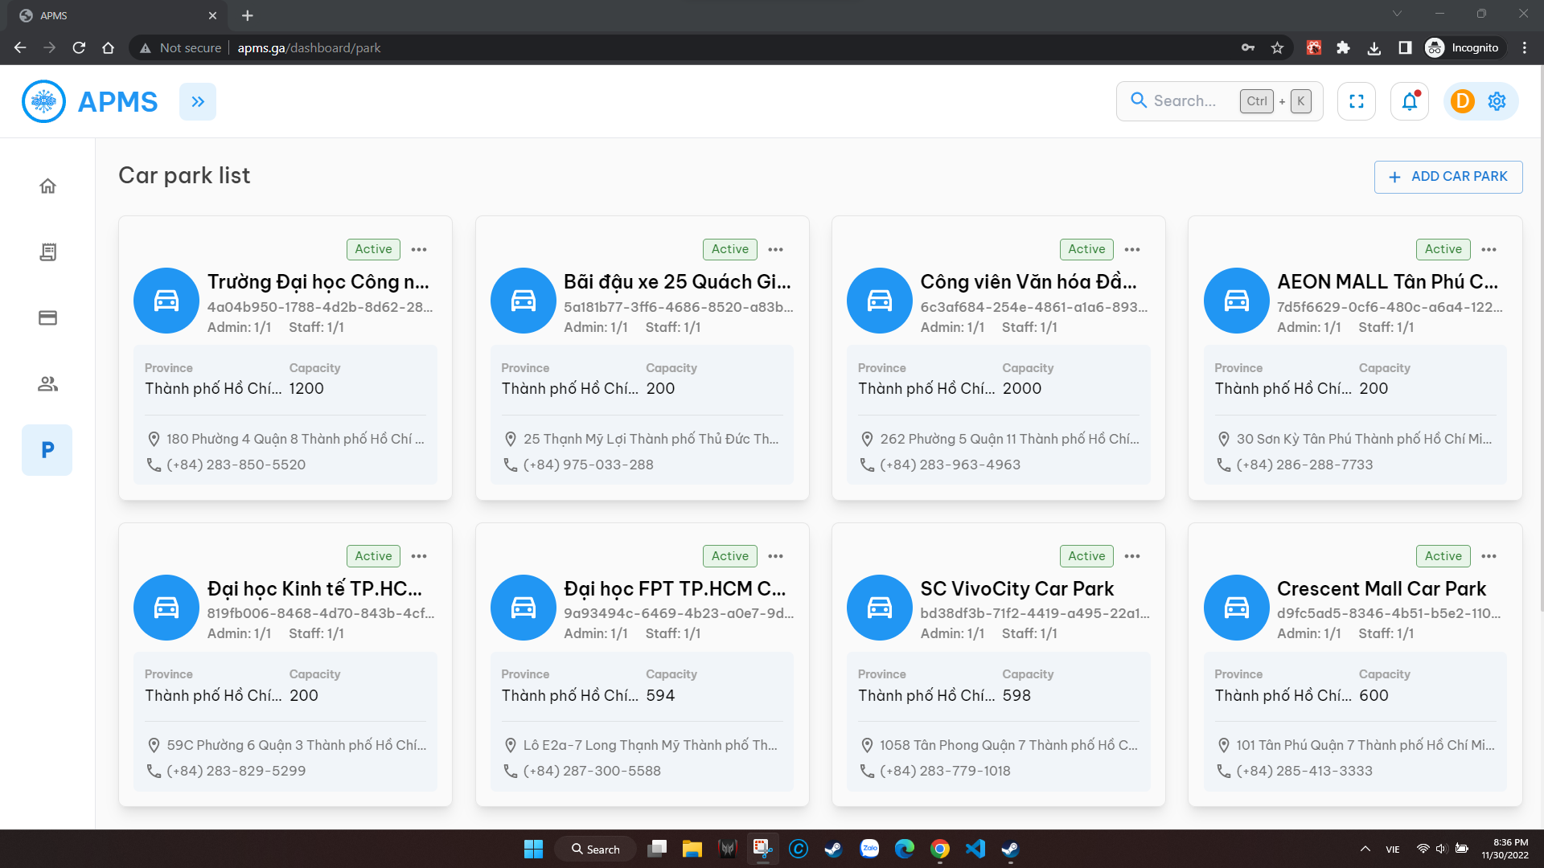

*Figure 32. Car Park List screen*

* + - **Function details:**

Buttons/Links:

| **#** | **Function** | **Description** | **Validation** | **Outcome** |
| --- | --- | --- | --- | --- |
| 1 | Add car park | Click to go to add car park form | No | Pop up a form to add a car park |
| 2 | Edit car park | Click to edit the car park | No | Display a form to edit the selected car park |

### 

### 3.9 Get ticket list

* + - **Function trigger:** Click on “Ticker List” on left menu
    - **Function description:** System displays list of tickets currently in the system
    - **Screen Layout:**

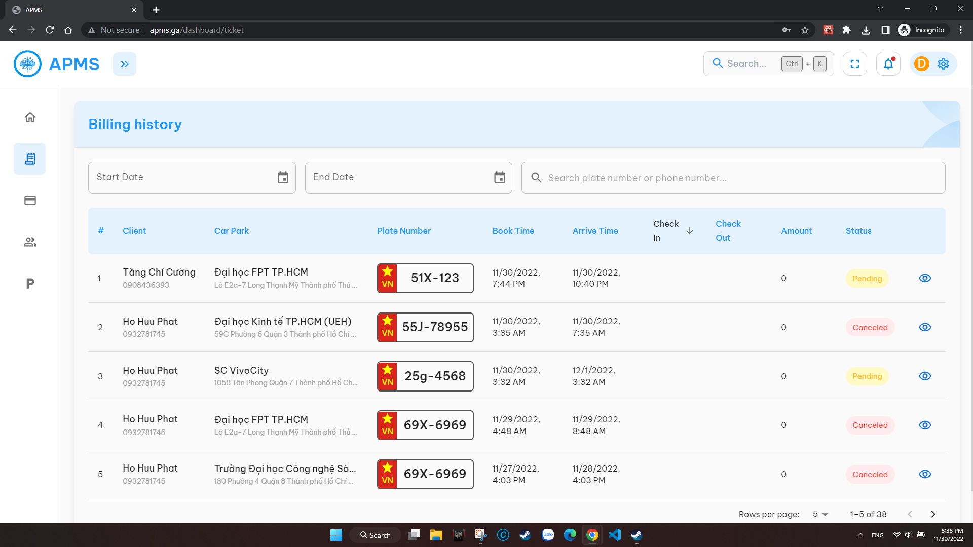

*Figure 33. Ticket List screen*

* + - **Function details:**

Fields:

| **#** | **Field name** | **Description** | **Read only** | **Mandatory** | **Control type** | **Data type** |
| --- | --- | --- | --- | --- | --- | --- |
| 1 | Start Date | Choose start date to filter | No | No | Dropdown  list /Text box | Date |
| 2 | End Date | Choose end date to filter | No | No | Dropdown  list /Text box | Date |
| 3 | Search plate number or phone number | Fill plate number or phone number to search | No | No | Text box | String |

Buttons/Links:

| **#** | **Function** | **Description** | **Validation** | **Outcome** |
| --- | --- | --- | --- | --- |
| 4 | View ticket details | Click to go to get ticketing details | No | Pop-up ticket details |

### 

### 3.10 Get transaction history

* + - **Function trigger:** Click on “Transaction history” on left menu
    - **Function description:** System displays list of tickets currently in the system
    - **Screen Layout:**

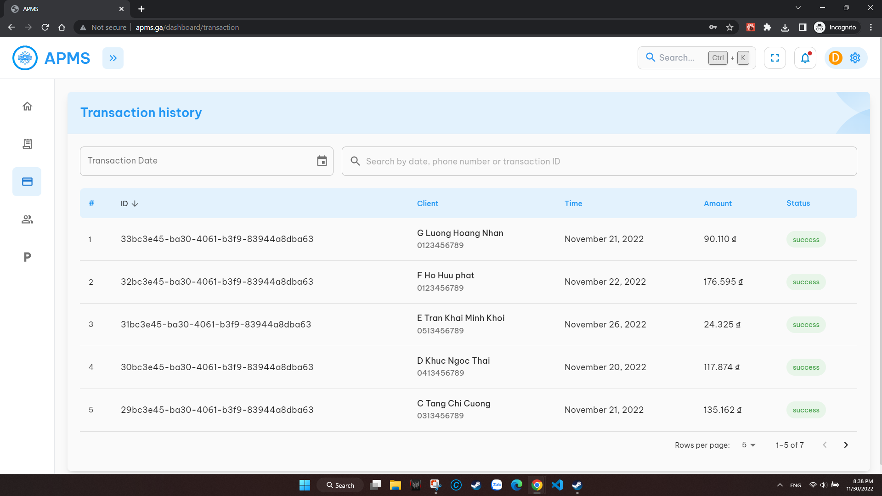

*Figure 34. Transaction History screen*

* + - **Function details:**

Fields:

| **#** | **Field name** | **Description** | **Read only** | **Mandatory** | **Control type** | **Data type** |
| --- | --- | --- | --- | --- | --- | --- |
| 1 | Transaction Date | Choose date to filter | No | No | Dropdown  list /Text box | Date |
| 2 | Search by date, phone number or transaction id | Fill date or phone number or transaction id to search | No | No | Text box | String |

Buttons/Links:

| **#** | **Function** | **Description** | **Validation** | **Outcome** |
| --- | --- | --- | --- | --- |
| 4 | View ticket details | Click to go to get ticketing details | No | Pop-up ticket details |

### 

### 3.11 Get employee list

* + - **Function trigger:** Click on “Employees” on left menu
    - **Function description:** System displays list of employees currently in the system
    - **Screen Layout:**

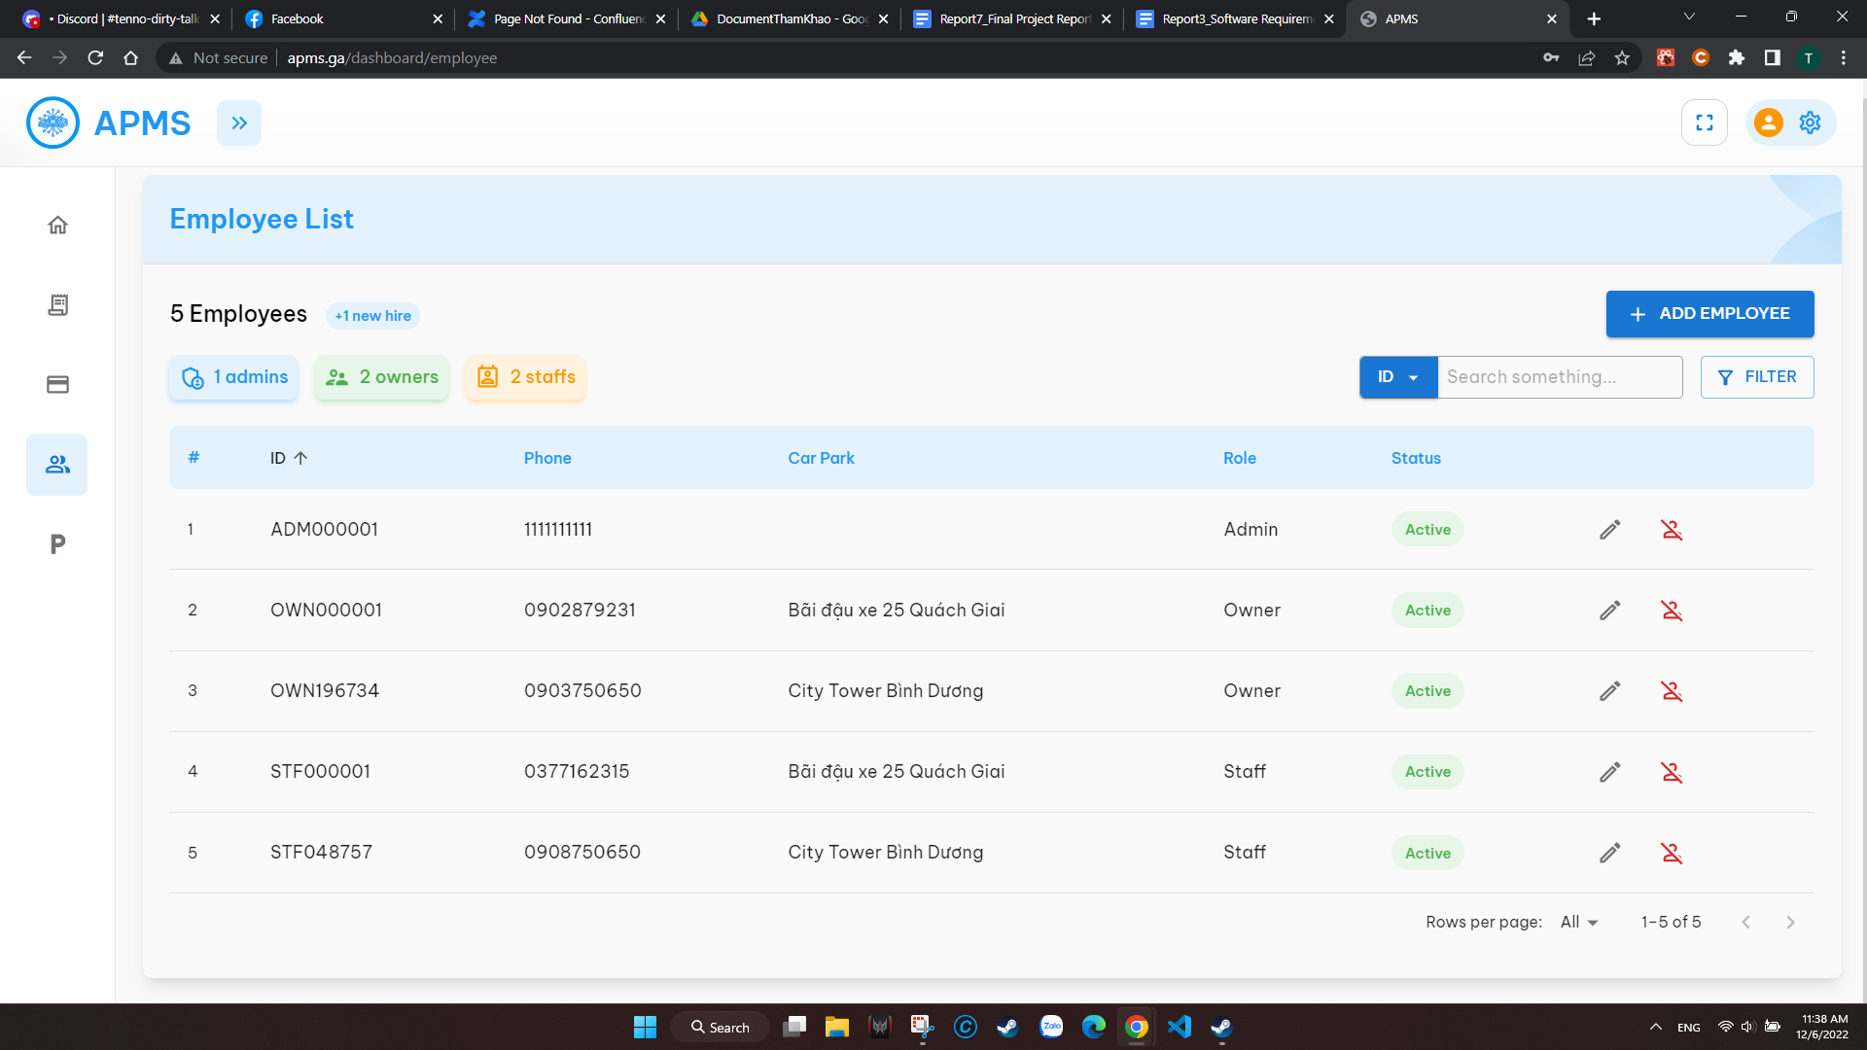

*Figure 35. Employee List screen*

* + - **Function details:**

Fields:

| **#** | **Field name** | **Description** | **Read only** | **Mandatory** | **Control type** | **Data type** |
| --- | --- | --- | --- | --- | --- | --- |
| 1 | Search | Search for employee’s id or phone number | No | No | Dropdown  list /Text box | String |
| 2 | Filter | Choose a status filter | No | No | Dropdown  list |  |

Buttons/Links:

| **#** | **Function** | **Description** | **Validation** | **Outcome** |
| --- | --- | --- | --- | --- |
| 3 | Edit employee | Click to edit employee information | No | Pop-up employee information |
| 4 | Deactivate employee | Click to deactivate an employee | Yes | Notify deactivating confirmation |
| 5 | Add employee | Click to add a new employee | No | Pop-up employee form |

### 3.12 Show owner reports

* + - **Function trigger:** Click on “Dashboard” on left menu
    - **Function description:** System displays monthly tickets and revenue; system overview; chart of revenue; transaction details
    - **Screen Layout:**

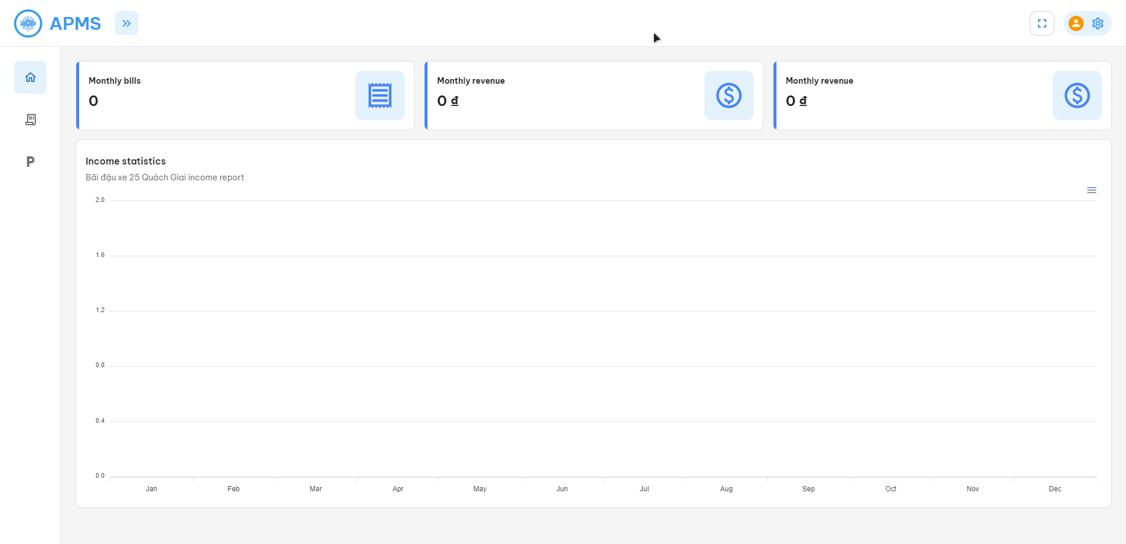

*Figure 36. Owner Dashboard screen*

### 3.13 Show staff’s reports

* + - **Function trigger:** Click on “Dashboard” on left menu
    - **Function description:** System displays booking list of current day, scanned plate and car park overview
    - **Screen Layout:**

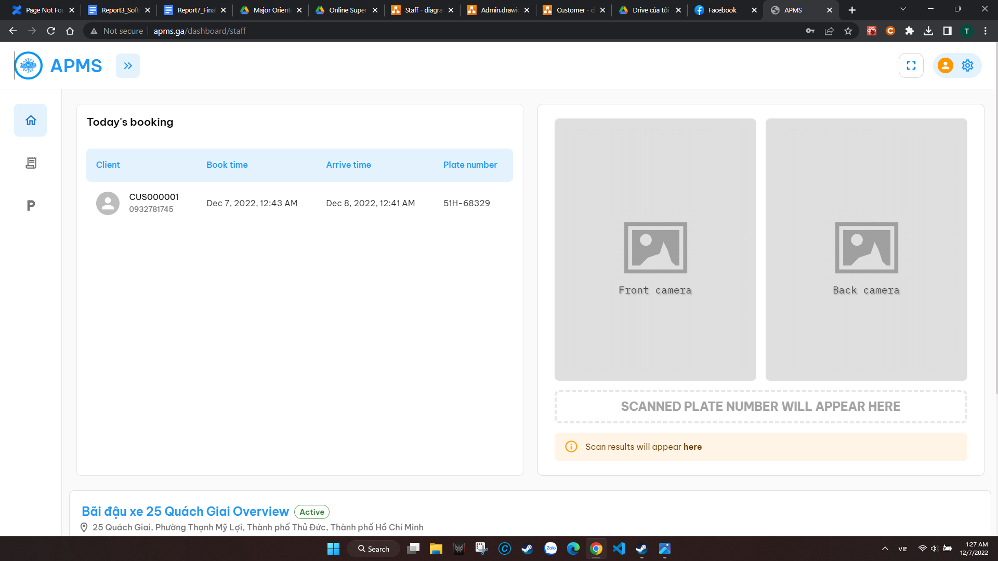

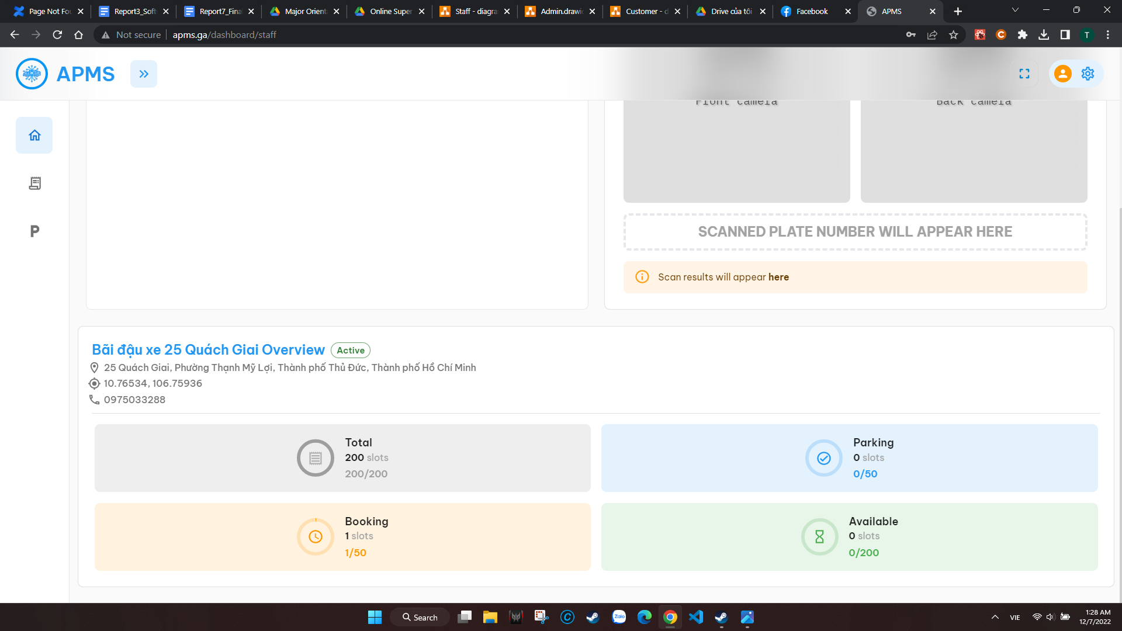

*Figure 37-38. Staff Dashboard screen*

### 

### 3.14 Manage car park

* + - **Function trigger:** Click on “My park” on left menu
    - **Function description:** System displays list of employees of the car park. There are 2 forms to view and update fee and car park’s information
    - **Screen Layout:**

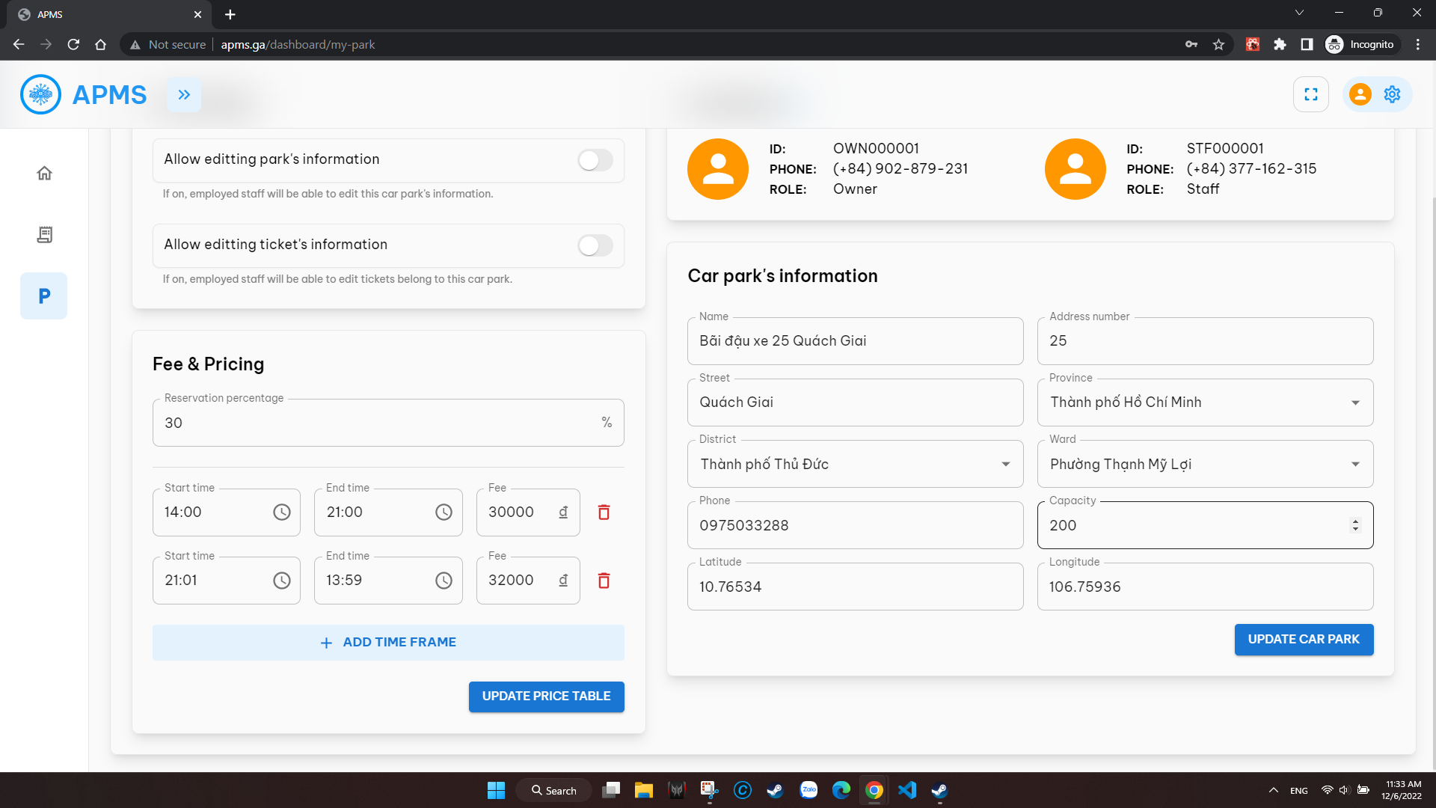

*Figure 39. My Park screen*

* + - **Function details:**

Fields:

| **#** | **Field name** | **Description** | **Read only** | **Mandatory** | **Control type** | **Data type** |
| --- | --- | --- | --- | --- | --- | --- |
| 1 | Reservation percentage | Fill Reservation percentage | No | Yes | Text box | Number |
| 2 | Start time | Fill or choose start time | No | Yes | Clock/Text box | String |
| 3 | End time | Fill or choose end time | No | Yes | Clock/Text box | String |
| 4 | Fee | Enter fee for the time frame | No | Yes | Text box | Number |
| 5 | Name | Enter car park’s name | No | Yes | Text box | String |
| 6 | Address number | Enter car park’s address number | No | Yes | Text box | String |
| 7 | Street | Enter car park’s street | No | Yes | Text box | String |
| 8 | Province | Choose a province | No | Yes | Dropdown/Text box | String |
| 9 | District | Choose a district | No | Yes | Dropdown/Text box | String |
| 10 | Ward | Choose a ward | No | Yes | Dropdown/Text box | String |
| 11 | Phone | Enter car park’s phone number | No | Yes | Text box | Number |
| 12 | Capacity | Enter car park’s slot capacity | No | Yes | Text box | Number |
| 13 | Latitude | Enter Latitude | No | Yes | Text box | Number |
| 14 | Longitude | Enter Longitude | No | Yes | Text box | Number |

Buttons/Links:

| **#** | **Function** | **Description** | **Validation** | **Outcome** |
| --- | --- | --- | --- | --- |
| 15 | Remove time frame | Click to remove time frame | No | Remove an existed time frame |
| 16 | Update | Click to update the car park’s time for the time frame | Yes | Update the time frame based on Actor input |
| 17 | Add time frame | Click to create a new time frame | Yes | Create a new line of form for new time frame |
| 18 | Update car park | Click to update the car park’s information | Yes | Update the car park based on Actor input |

## 4. Non-Functional Requirements

### 4.1 External Interfaces

* File Storage Service: The system can be integrated with Firebase Storage.
* The system can use HTTP to transfer data.

### 4.2 Quality Attributes

#### 4.2.1 Usability

* The web application for staff and car park owners should require no more than one day of training to be used
* The mobile application for customers should be used without training

#### 4.2.2 Reliability

* The license plate recognition system should be 92% or higherunder normal conditions (the number plate must comply with the Vietnamese law and completely visible, under good lighting condition)

#### 4.2.4 Compatibility

* The mobile application should be compatible with Android 8 and higher
* The web applications should work well with Chrome Browser version 65 and higher, Firefox 52 and higher, Microsoft Edge version 91 or higher

#### 4.2.5 Security

* All input data are validated before being saved to the database
* All passwords will be hashed using a combination of SHA256 and salt
* The system continuously checks for authentication and authorization before executing any features.

## 5. Requirement Appendix

### 5.1 Business Rules

### 

| **ID** | **Rule Definition** |
| --- | --- |
| BR-01 | Only car with a Vietnamese license plate can be registered |
| BR-02 | Only staff can modify check-in/check-out requests in some special conditions |
| BR-03 | Any issues happen in the parking process that are not related to our system will not be considered as our responsibility |
| BR-04 | Reservation fee is not refundable unless the ticket is canceled by staff |
| BR-05 | The booking will be automatically canceled after 30 minutes of the registered arrival time if no check-in request for the ticket is recorded, and considered as a customer cancellation request |
| BR-06 | If the customer actual arrival time exceeds the registered arrival time by more than 5 minutes and less than 30 minutes, an overdue fee will be added to the total parking fee |
| BR-07 | Overdue fee is the parking fee of one hour |
| BR-08 | Customers’ mobile device must be connected to the internet in order to use the system |
| BR-09 | Mobile device must support QR code scanning |
| BR-10 | Parking time is rounded up to hour |
| BR-11 | When the parking fee of a car park is changed, the parking fee of all tickets of that car park created before the change will not be affected |
| BR-12 | When the available slots count equals 0, only the customer who booked a parking slot in advance can check-in |
| BR-13 | The reservation fee must be paid at the time that the customer books a parking slot |
| BR-14 | Customers can only book a parking slot within 24 hours prior to the check-in time |
| BR-15 | One license plate can only be checked in at one car park at a time |
| BR-16 | The parking fee is calculated based on the actual check-in time and check-out time |
| BR-17 | Reservation fee is calculated by the percentage of parking fee calculated from the time of the booking to the scheduled check-in time, set by the owner of the car park |
| BR-18 | Parking fee can only be paid using application’s electronic wallet |
| BR-19 | Customers cannot book a slot if their account balance is not enough for the reservation fee |
| BR-20 | Customers cannot check-out if their account balance is not enough for the parking fee |
| BR-21 | The system requires Internet connection and electricity to function normally |
| BR-22 | The revenue earned by the car park (minus the system operation fee) will be paid to the owner monthly (the 1st day of every month) |
| BR-23 | After a top-up transaction is made, a refund is not eligible under any circumstances |
| BR-24 | Only USD is acceptable for a top-up transaction. The conversion rate from VND to USD will be fetched from Forex (https://www.forex.com) |
| BR-25 | The system does not support transferring money from one account to another |

### 5.2 Application Messages List

### 

| **#** | **Message code** | **Message Type** | **Context** | **Content** |
| --- | --- | --- | --- | --- |
| 1 | MSG01 | In red, under the text box | Wrong confirmation password | *Confirmation password not match* |
| 2 | MSG02 | In red, under the text box | The * field is required. | *Input-required fields are empty* |
| 3 | MSG03 | In red, above submit button | Wrong OTP code | *Confirmation code is incorrect* |
| 4 | MSG04 | Toast message | Cancel a booking successfully | *Cancel booking successfully* |
| 5 | MSG05 | Toast message | Create new password successfully | *Create a new password successfully. Please log in with newly created password* |
| 6 | MSG06 | In red, under the text box | Validate phone number | *Phone number needs to be from 9 to 10 numbers* |
| 7 | MSG07 | In red, under the text box | Validate password | *Password needs to be from 6 to 10 characters* |
| 8 | MSG08 | In red, under the text box | Validate confirm password | *Confirm password does not match* |
| 9 | MSG09 | In red, above submit button | No account found to reset password | *No account found with given phone number* |
| 10 | MSG10 | Toast message | Update password successfully | *Your password has been changed* |
| 11 | MSG11 | In red, above submit button | Invalid login credential | *Incorrect phone number or password!* |
| 12 | MSG12 | In red, under the text box | Validate name | *Name needs to be at least 3 characters* |
| 13 | MSG13 | Toast message | Send feedback successfully | *Thank you for your contribution* |
| 14 | MSG14 | In red, under the text box | Validate feedback’s description | *Please enter your opinion in the field above!* |
| 15 | MSG15 | Popup | Confirm plate number for check in | *Is this the license plate you want to check-in:{plate number}* |
| 16 | MSG16 | Popup | Confirm plate number for check out | *Is this the license plate you want to check-out:{plate number}* |
| 17 | MSG17 | Toast message | Check-in failed | *Check-in Failed* |
| 18 | MSG18 | Toast message | Check-out failed | *Check-out Failed* |

# IV. Software Design Description

## 1. System Design

### 1.1 System Architecture

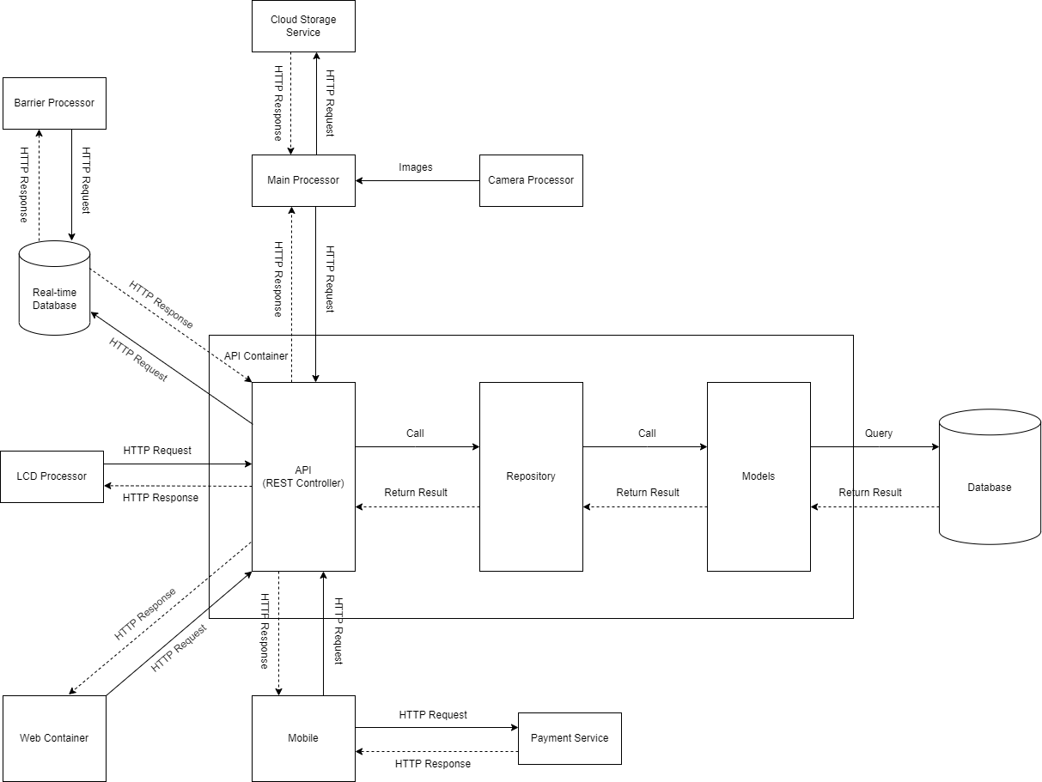

*Figure 40. System architecture overview diagram*

### 1.2 Package Diagram

#### 1.2.1 Back-end

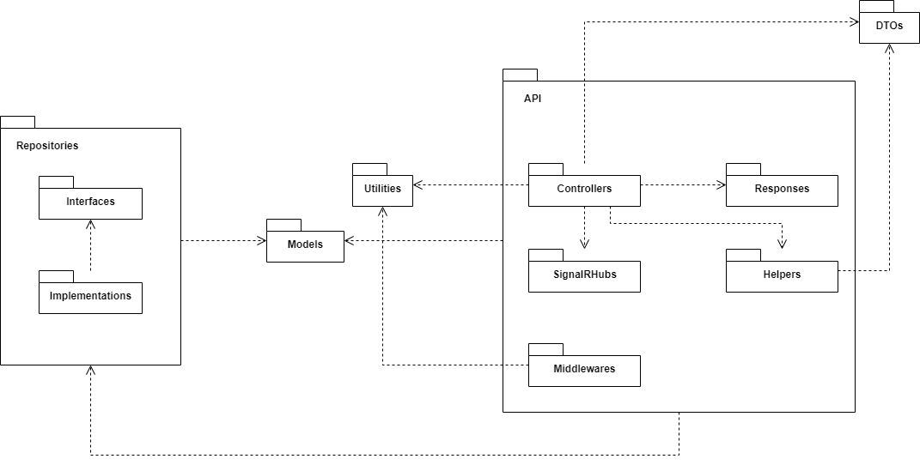

*Figure 41. Package diagram (Backend)*

Ref: [Unified Modeling Language, v2.5.1 (omg.org)](https://www.omg.org/spec/UML/2.5.1/PDF)

***Package Descriptions***

| **No** | **Package** | **Description** |
| --- | --- | --- |
| 01 | Models | A project that contains entity models that match database tables and a DbContext class to access the database |
| 02 | Repositories | A project that contains classes and interfaces that manipulate data in the database |
| 03 | Interfaces | Contained inside the Repositories project, contains interfaces for data manipulation classes |
| 04 | Implementations | Contained inside the Repositories project, contains classes that implement the interfaces contained in the Interfaces packages |
| 05 | Utilities | Contained classes that perform password hashing and other application constants |
| 06 | DTOs | Contained contracts that are mapped from the entity classes to be returned in the controllers |
| 07 | API | Contains controllers, middlewares, services that help send data to clients and process data from clients |
| 08 | Controllers | Contained in the API project. Contains classes and controllers that receive data from clients, manipulate and return data to the clients |
| 09 | SignalRHubs | Contains SignalR Hubs to execute real-time functionalities |
| 10 | Middlewares | Contains custom middlewares of the API project |
| 11 | Responses | Contains classes that represent the results returned from the API to the clients |
| 12 | Helpers | Contains classes that provide some utilities for the API project |

#### 1.2.2 Front-end

*Figure 42. Package diagram (Frontend)*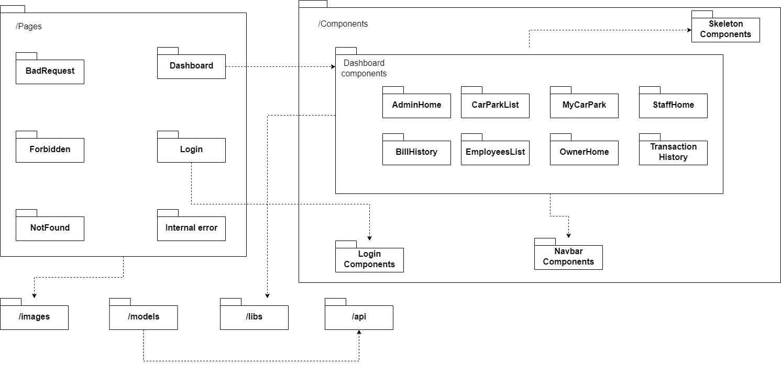

***Package Descriptions***

| **No** | **Package** | **Description** |
| --- | --- | --- |
| 01 | Pages | Root folder for all pages of the website |
| 02 | Dashboard | Folder contains all dashboard tabs and serves as a skeleton for the website |
| 03 | Login | Folder contains login page to authenticate and authorize users |
| 04 | Components | Root folder contains all components which are used throughout the website |
| 05 | Images | Contains placeholder and images for the website |
| 06 | Models | Contains models for redux global state management |
| 07 | Libs | Utilities and tools for formatting data |
| 08 | Api | Settings and constants for calling back-end API |

#### 1.2.3 Mobile

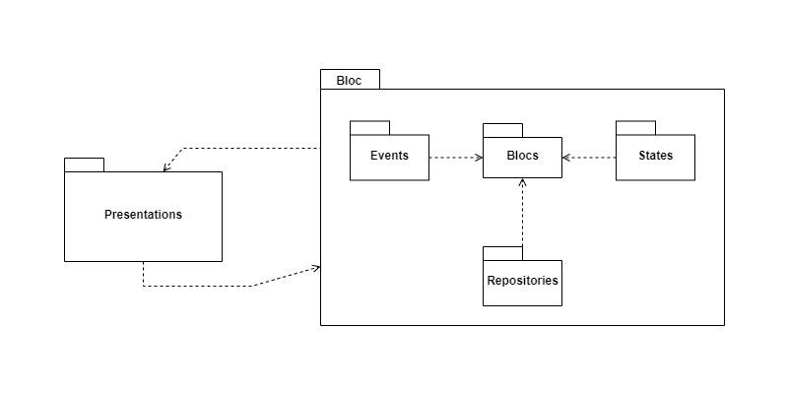

*Figure 43.* *Package diagram (Mobile)*

| **No** | **Package** | **Description** |
| --- | --- | --- |
| 01 | Presentations | Contains all screen for user to interact and represent data from database |
| 02 | States | Represent all states that objects can have in the application |
| 03 | Events | Actions can occur in the application |
| 04 | Repositories | Intermediary for reading, writing database |
| 05 | Blocs | Connect 3 packages : states, event, repositories; let the application know which event will return which state and when to operate actions with the database. |

#### 1.2.4 IoT

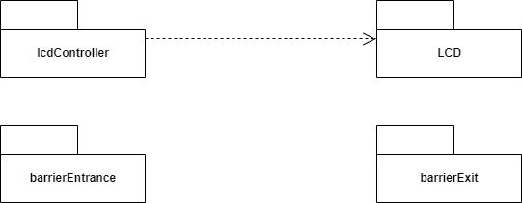

*Figure 44. Package diagram (IoT)*

***Package Descriptions***

| **No** | **Package** | **Description** |
| --- | --- | --- |
| 01 | LCD | Contains code to display data on the LCD screen |
| 02 | lcdController | Contains code to fetch data from API and display the data onto the LCD screen |
| 03 | barrierEntrance | Contains code that controls the barrier at the entrance |
| 04 | barrierExit | Contains code that controls the barrier at the exit |

## 2. Database Design

*Figure 45. Database diagram*

Link to diagram: [Database Diagram](https://drive.google.com/file/d/1iQYvclyU1iBAmVSDOueUb-qlCE5j7Yuk/view?usp=share_link)

***Table Descriptions***

| **No** | **Table** | **Description** |
| --- | --- | --- |
| 01 | CarPark | Includes all information of a car park  - Fields:   * + Id: ID of the car park, generated by the system   + Name   + Address number   + Street   + Ward   + District   + City   + Latitude: latitude of the car park on the map, used to calculate the distance between customer’s current destination to the car park   + Longitude: longitude of the car park on the map, used to calculate the distance between customer’s current destination to the car park   + PhoneNumber   + MaxCapacity: Maximum slots count of the car park   + AvailableSlotsCount: current empty slots of the car park   + Status: status of the car park, active or removed * Primary keys: Id * Foreign keys: None |
| 02 | PriceTable | Each car park has a price table to calculate reservation fee and parking fee   * Fields:   + CarParkId: ID of the car park of the price table   + ReservationFeePercentage: percentage of the parking to calculate the reservation fee of each tickets   + FeePerHour: parking fee per hour   + LastModified: the last time the price table is modified * Primary key: CarParkId * Foreign key: CarParkId |
| 03 | PriceTableDetail | If owner of the car park does not want to set a fixed parking fee, they can create price table details to calculate parking fee by a time interval   * Fields:   + CarParkId: ID of the car park of the price table   + FromTime: starting time of the time interval   + ToTime: ending time of the time interval   + Fee: parking fee in this time interval * Primary key: CarParkId * Foreign key: CarParkId |
| 04 | Ticket | Includes all information of a parking ticket   * Fields:   + Id: ID of the ticket   + CarParkId: ID of the car park the ticket belongs to   + AccountId: ID of the customer account the ticket belongs to   + PlateNumber: plate number of the vehicle used to book or check in   + BookTime: the time customer books a slot   + ArriveTime: scheduled time of arrival set by the customer   + StartTime: actual check-in time   + EndTime: check-out time   + PicInUrl: link to the image of the vehicle, captured when customer checks in   + PicOutUrl: link to the image of the vehicle, captured when customer checks out * ReservationFee: fee applied when customer books a slot * TotalFee: total parking fee, calculated when customer checks out * PriceTable: price table of the ticket’s car park at the time of creation * OverdueFee: fee charged when the actual check in time is later than the scheduled arrival time * CancellerAccountId: ID of the account who cancels the ticket * Status: status of the ticket: pending, checked-in, checked-out or canceled * Primary key: Id * Foreign keys: CarParkId, AccountId |
| 05 | Account | Includes all information of a user of the account   * Fields:   + Id: ID of the account, is generated automatically based on role, is used to authentication by admin, staff and owner   + Password: password of the account, is used for authentication   + Salt: generated by the system, used to enhance security of the system, is unique for each account   + PhoneNumber: phone number of the user, unique for each account, is used for authentication by customer   + RoleId: ID of the role of the account   + CanEdit: represents whether the account is allowed to edit and create tickets of their own car park   + CanEditCarPark: represents whether the account is allowed to edit car park, staff and owner can only edit their own car park   + CarParkId: ID of the car park the account is working at, applied for staff and owner   + Active: represents whether the account is allowed to access the system or not * Primary key: Id * Foreign key: CarParkId, RoleId |
| 06 | UserInfo | Includes full name and account balance of the account who has the customer role   * Fields:   + Id: ID of the account   + FullName: full name of the customer   + AccountBalance: account balance of the account, is used to pay for parking and reservation fee * Primary key: Id * Foreign key: Id |
| 07 | LicensePlate | Represents license plate that an account has used to book or check in at a car park   * Fields:   + AccountId   + PlateNumber: number of the license plate account has used   + UsageCount: the number of times the account has used the plate number * Primary keys: PlateNumber, AccountId * Foreign key: AccountId |
| 08 | Parking | Represents the number of times the account has parked at a car park   * Fields:   + AccountId   + CarParkId   + UseCount: the number of times the account has parked at the car park * Primary keys: CarParkId, AccountId * Foreign keys: CarParkId, AccountId |
| 09 | Transaction | Includes all information of a transaction, created whenever the user tops up their balance, books a slot or checks out at a car park   * Fields:   + Id: ID of the transaction   + TransactionTime: the time the transaction is made   + AccountId: ID of the account who makes the transaction   + TransactionType: type of the transaction: Top-up, booking, parking fee   + TicketId: ID of the ticket the transaction is paying for * Primary key: Id * Foreign keys: AccountId, TicketId |
| 10 | Feedback | Represents the feedback the users create about the system   * Fields:   + Id: ID of the feedback   + Description: what the feedback is about   + Time: the time the feedback is created   + AccountId: ID of the account who makes the feedback * Primary key: Id * Foreign key: AccountId |
| 11 | Role | Represents the role of each account. Used for authorization, determine the account can access which functions   * Fields:   + Id: ID of the role   + Title: title of the role * Primary key: Id |

## 3. Detailed Design

### 3.1 Check-in

#### 3.1.1 Class Diagram

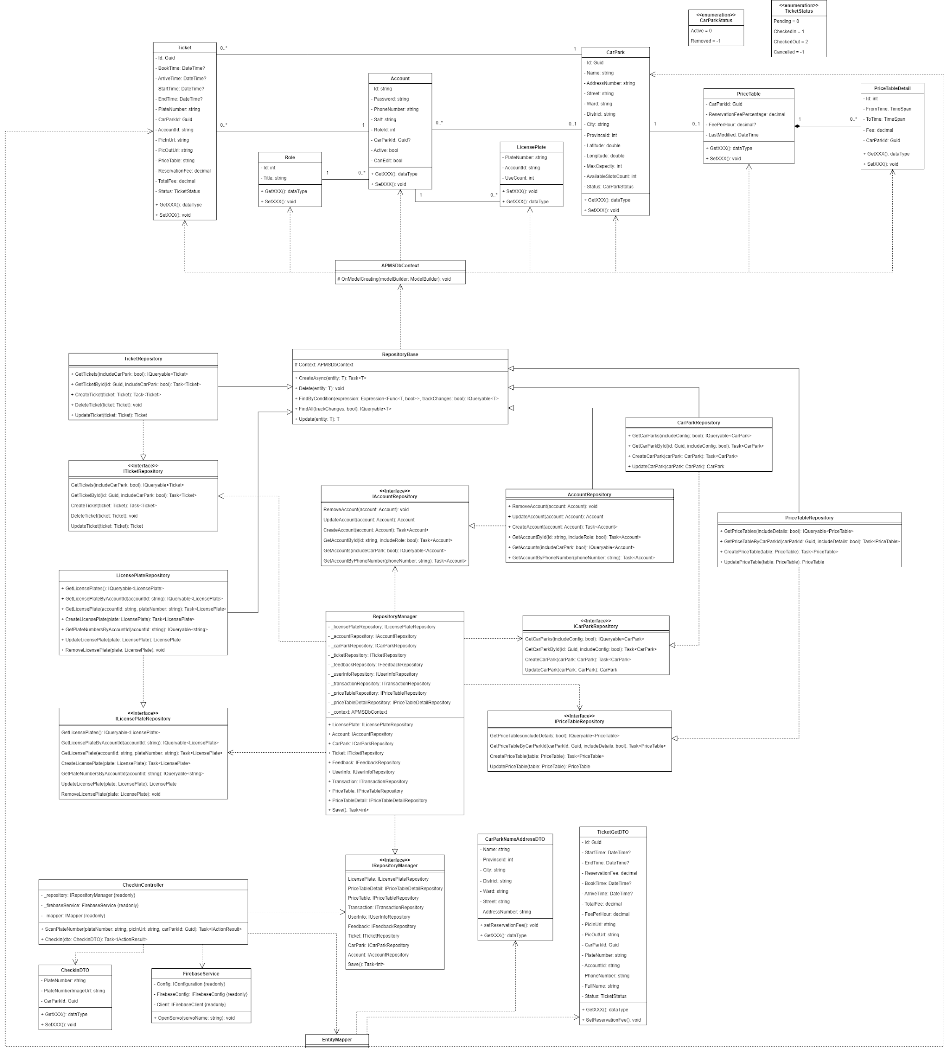

*Figure 46. Class diagram*

Ref: [Unified Modeling Language, v2.5.1 (omg.org)](https://www.omg.org/spec/UML/2.5.1/PDF)

Link to diagram: [Check-in Class Diagram](https://drive.google.com/file/d/1I6l4sHuGv27LVOvHvSW7n7615Ij2dMtl/view?usp=share_link)

#### 3.1.2 Sequence Diagram

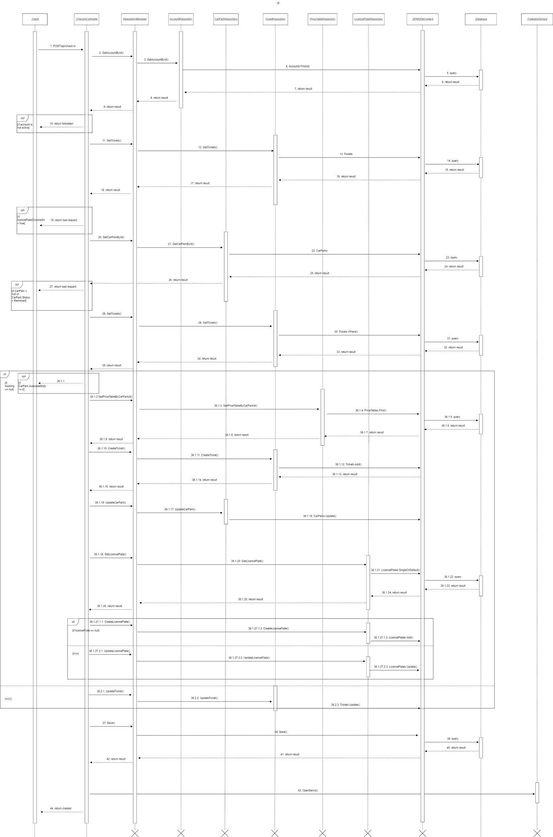

*Figure 47. Check-in sequence diagram*

Ref: [Unified Modeling Language, v2.5.1 (omg.org)](https://www.omg.org/spec/UML/2.5.1/PDF)

Link to diagram: [Check-in Sequence Diagram](https://drive.google.com/file/d/1EuxpKOhohdCwDFfb_SEuXgyqNxwY6011/view?usp=share_link)

### 3.2 Check-out

#### 3.2.1 Class Diagram

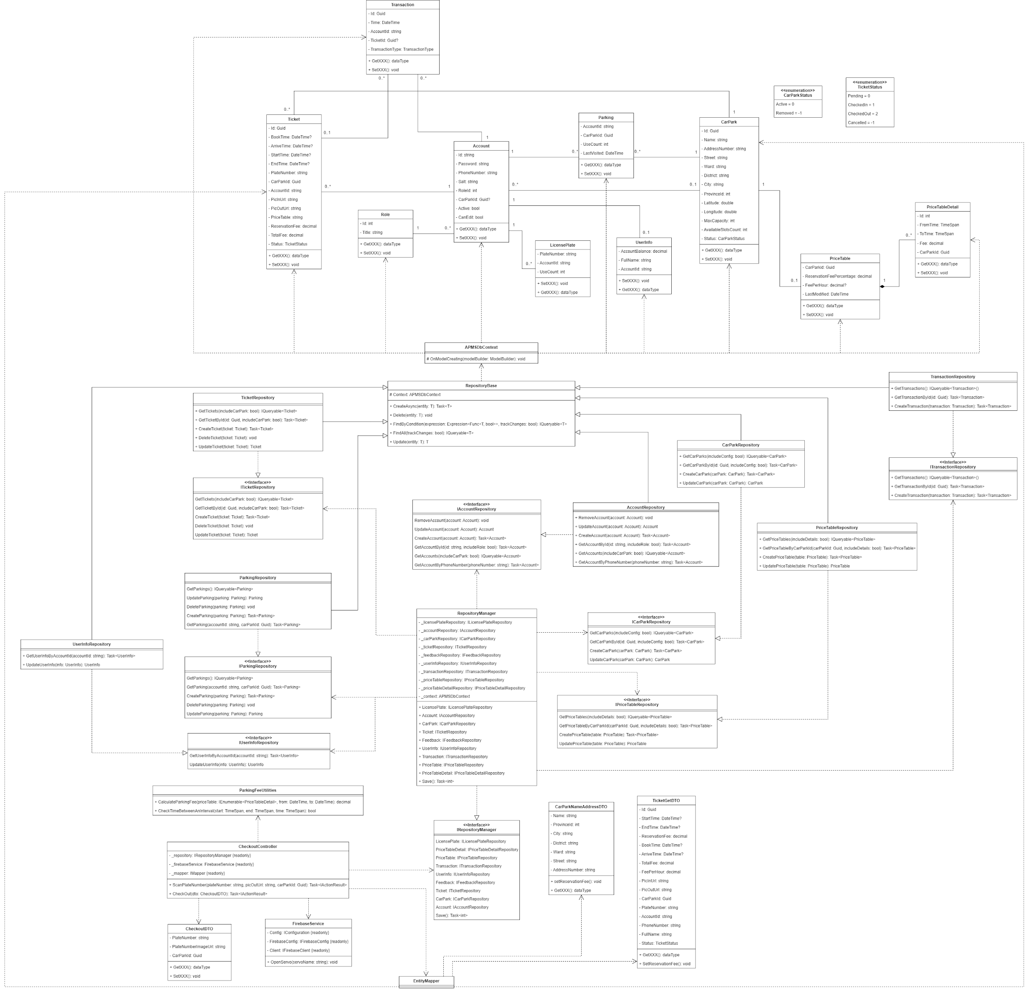

*Figure 48. Check-out class diagram*

Ref: [Unified Modeling Language, v2.5.1 (omg.org)](https://www.omg.org/spec/UML/2.5.1/PDF)

Link to diagram: [Check-out Class Diagram](https://drive.google.com/file/d/1YuTEcIbPlIJ1MdGopaPsNrE2BnHqWrtD/view?usp=share_link)

#### 3.2.2 Sequence Diagram

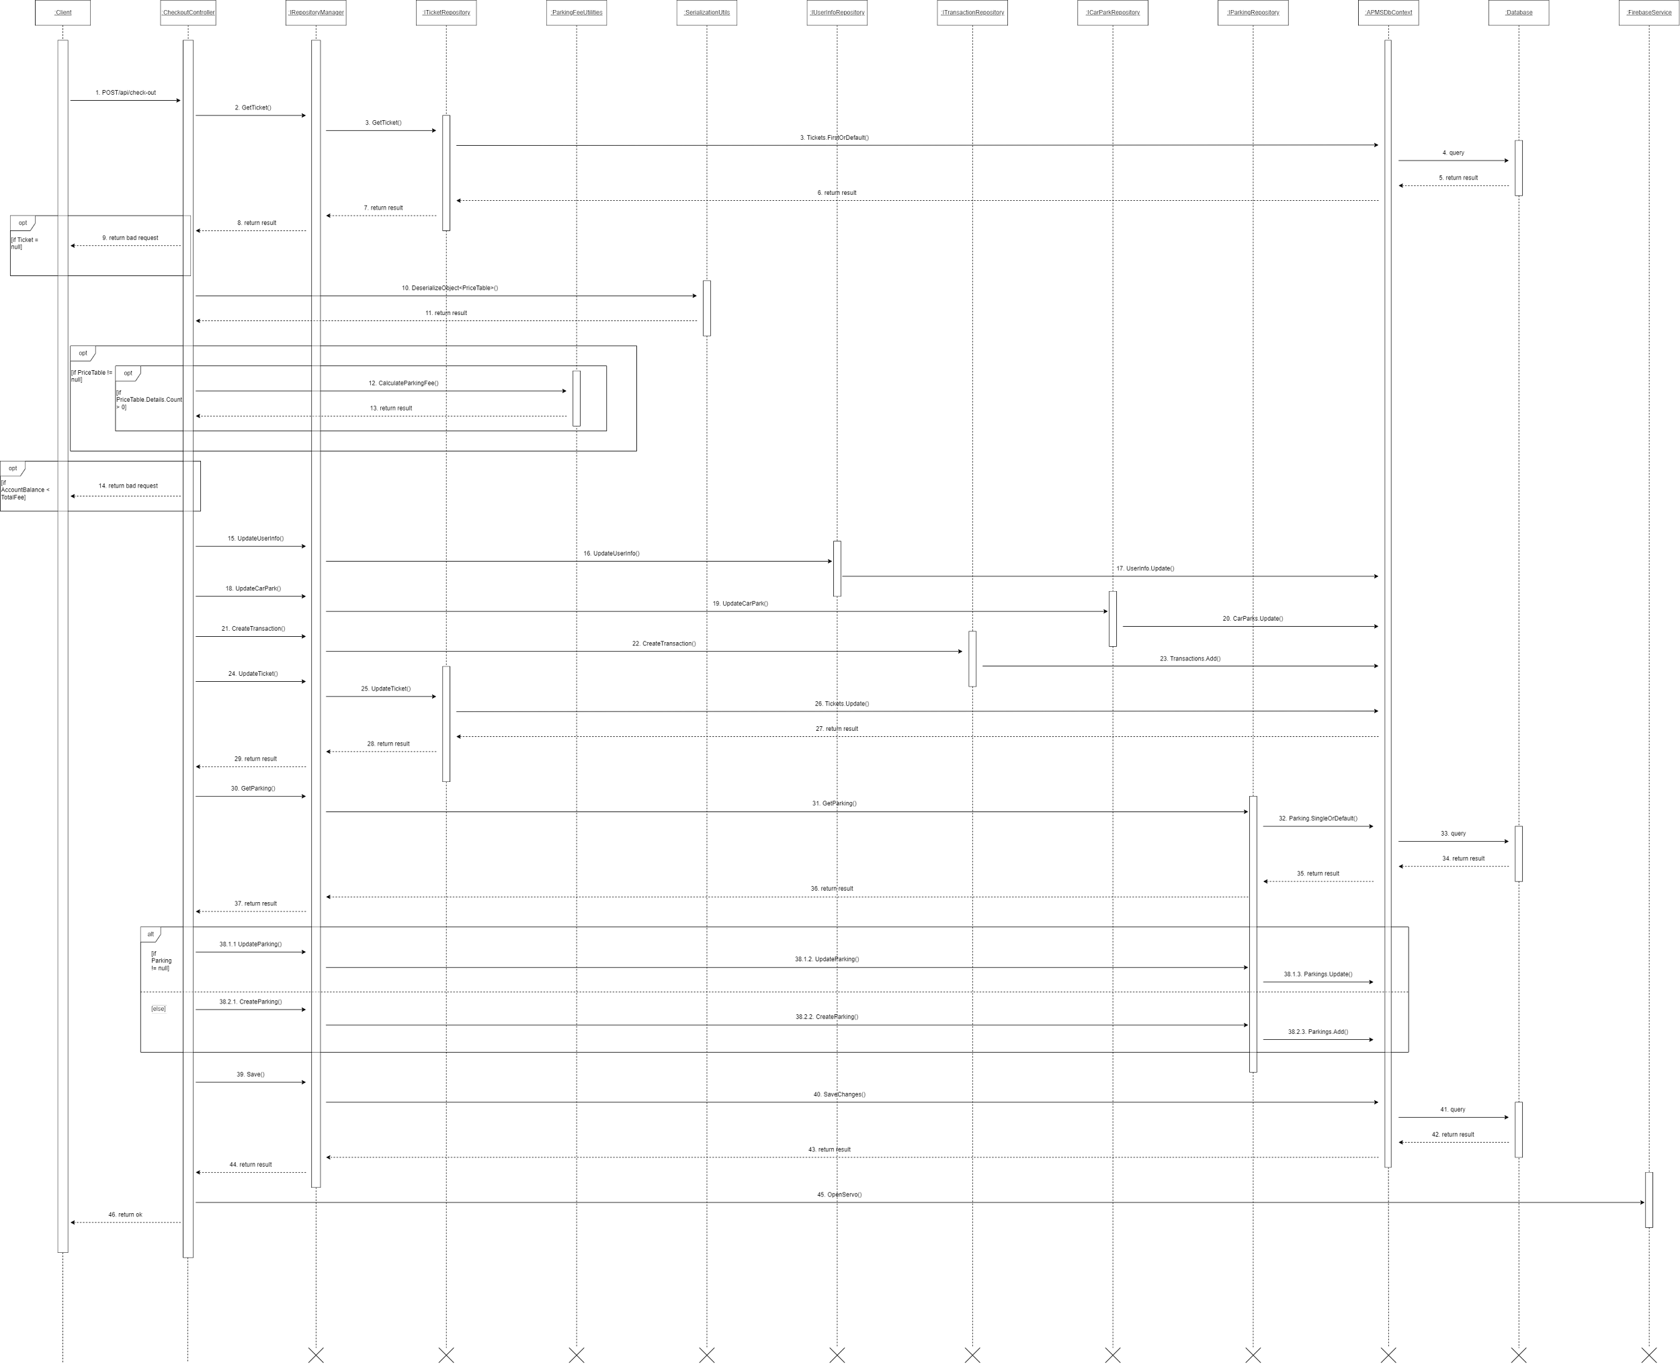

*Figure 49. Check-out sequence diagram*

Ref: [Unified Modeling Language, v2.5.1 (omg.org)](https://www.omg.org/spec/UML/2.5.1/PDF)

Link to diagram: [Check-out Sequence Diagram](https://drive.google.com/file/d/1FqwVOPPsE5iaoMwB5BAFlo9_ViHtVQQB/view?usp=share_link)

### 3.3 Booking

#### 3.3.1 Class Diagram

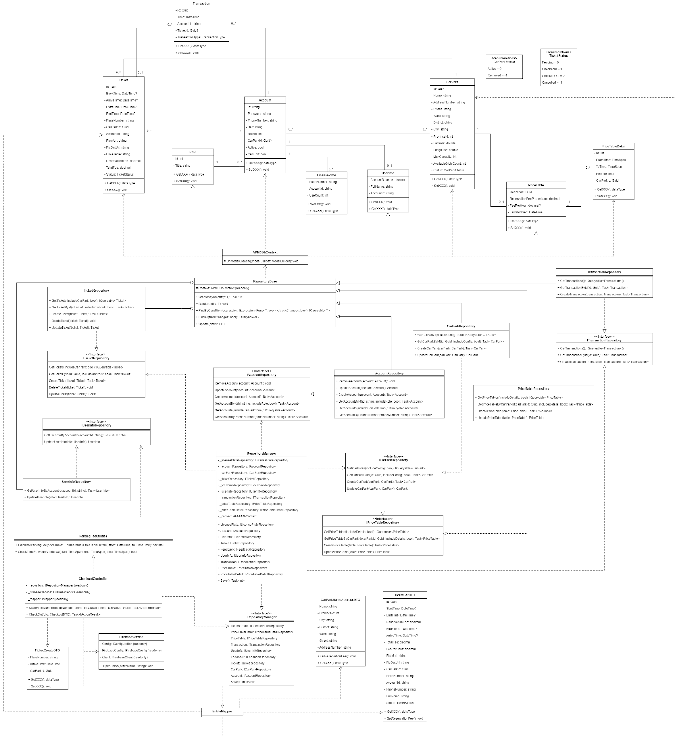

*Figure 50. Booking class diagram*

Ref: [Unified Modeling Language, v2.5.1 (omg.org)](https://www.omg.org/spec/UML/2.5.1/PDF)

Link to diagram: [Booking Class Diagram](https://drive.google.com/file/d/1i5tIFpDcWbepEb8Ur6v0DgjLvE8kK4Lw/view?usp=share_link)

#### 

#### 3.3.2 Sequence Diagram

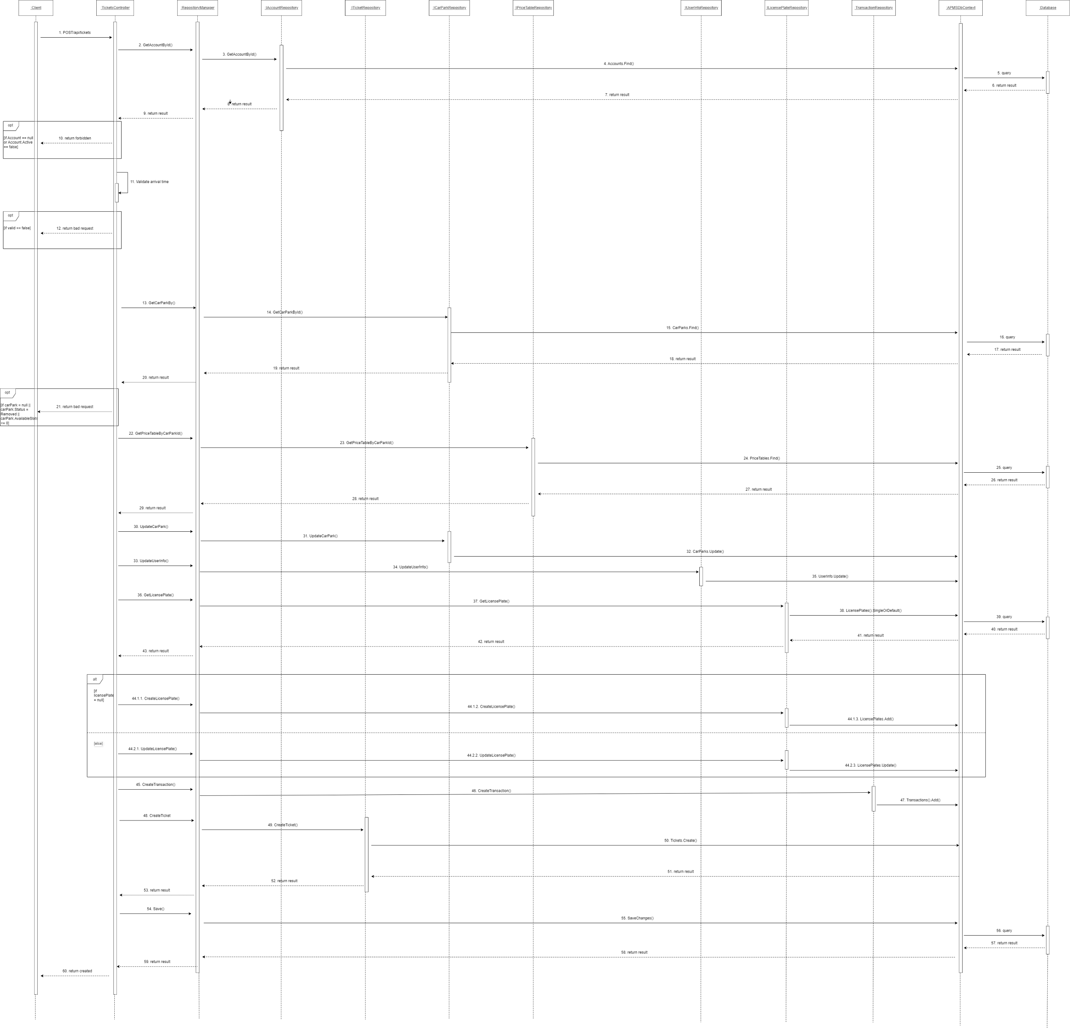

*Figure 51. Booking sequence diagram*

Ref: [Unified Modeling Language, v2.5.1 (omg.org)](https://www.omg.org/spec/UML/2.5.1/PDF)

Link to diagram: [Booking Sequence Diagram](https://drive.google.com/file/d/1AmCAmLSf0dSjToa7DXzV2eFxMD4TW27L/view?usp=share_link)

# 

# V. Software Testing Documentation

## 1. Scope of Testing

The target will mainly focus on the functions related to the web and mobile application’s features and nonfunctional requirements, including but not limited to:

* The functions listed in the functional requirements above (section 3 part III)
* Non-functional requirements listed in the non-functional requirements above (section 4 part III)
* Image processing and IoT related features

## 2. Test Strategy

### 2.1 Testing Types & Levels

* Test types: Functional testing
* Test levels: System testing

### 2.2 Supporting Tools

* Mobile application: Samsung Galaxy S21 FE (8GB/128GB, Android 12)
* Web application: Laptop Asus TUF FX505DT (16GB/512GB, Windows 11)
* IoT and image processing features:
* 2 IP KBVision KX-A2111N2 Megapixel cameras
* 2 Servo SG90 (barrier)
* 1 LG display monitor
* 1 LCD
* 1 Arduino Uno R3
* 2 ESP32
* Laptop Asus TUF FX505DT (16GB/512GB, Windows 11)

## 3. Test Plan

### 3.1 Human Resources

* Khúc Ngọc Thái: plan & construct test cases, verify results
* Tăng Chí Cường: execute tests and submit reports
* Hồ Hữu Phát: execute tests and submit reports
* Thuỷ Võ Anh Hoàng: execute tests and submit reports
* Nguyễn Quang Dũng: execute tests and submit report

### 3.2 Test Environment

* Mobile application: will be tested on a Samsung Galaxy S21 FE, running Android 12
* Web application: will be tested on a Laptop Asus TUF FX505DT, running Windows 11

### 3.3 Test Milestones

Able to construct a test report document before 10th of December, 2022

## 4. Test Cases & Test Reports

[APMS_TestReport](https://docs.google.com/spreadsheets/d/1fYVdcpkb_-5vAxm-bZhGnz4Nx5w9Rm0Q/edit?usp=share_link&ouid=110756811464633706076&rtpof=true&sd=true)

## 

## VI. Release Package & User Guides

## 1. Deliverable Package

| **No.** | **Item** | **Sub-item** | **Type** | **Version** |
| --- | --- | --- | --- | --- |
| Code package | | | | |
| 1 | Back-end | apms_backend.rar | zip | N/A |
| 2 | Front-end | apms_frontend.rar | zip | N/A |
| 3 | Mobile | apms_mobile.rar | zip | N/A |
| 4 | Image processing | dataset.rar | zip | N/A |
| 5 | Image processing | apms_imp.rar | zip | N/A |
| 6 | Embedded | embedded_system.rar | zip | N/A |
| Database scripts | | | | |
| 7 | Database | script.sql | sql | N/A |
| Document | | | | |
| 8 | Final report | Automatic-Parking-Management-and-Parking-Fee-Collection-System.pdf | pdf | N/A |
| 9 | Configuration | Configurations.docx | docx | N/A |
| Test | | | | |
| 10 | System test | APMS_TestReport.xlsx | xlsx | N/A |
| 11 | Validate AI model | Detect_Results.xlsx | xlsx | N/A |
| 12 | Validate AI model | validate_model.py | py | N/A |

## 2. Installation Guides

### 2.1 System Requirements

* Python version 3.7.xx or below (some packages aren’t compatible with the latest python version at the moment we install - current python version is 3.11.1)
* Windows operating system (either Windows 10 or Windows 11)
* Recommend using a computer with a strong GPU (Graphics Processing Unit) to have best experiences

### 2.2 Installation Instruction

#### 2.2.1 Install camera system

* Connect an IP camera to your internet router through the ethernet cable. Connect your computer to the wifi address of that router.

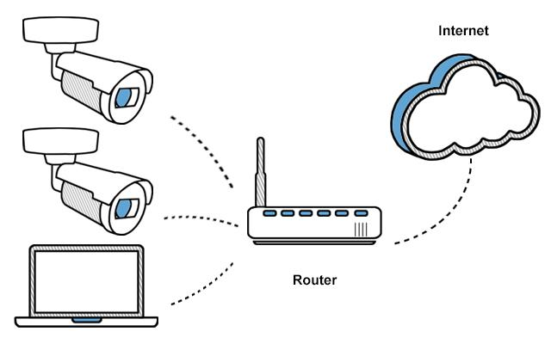

*Figure 52. Camera setup*

* Download KB Config Tool through this [link](https://kbvisiongroup.com/support/download-center.html) to configure your camera via your computer.
* Open KB Config Tool, you can get the camera’s IP address here.

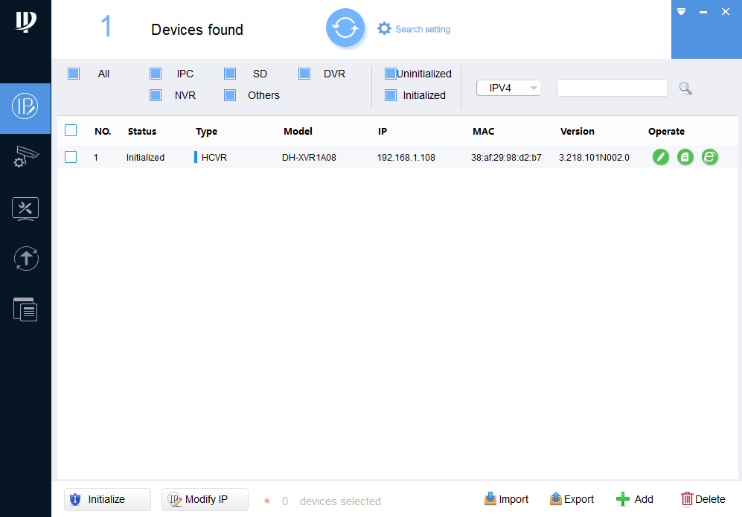

*Figure 53. KB Config Tool*

* Access that IP address (It’s <http://192.168.1.108> for the example above).

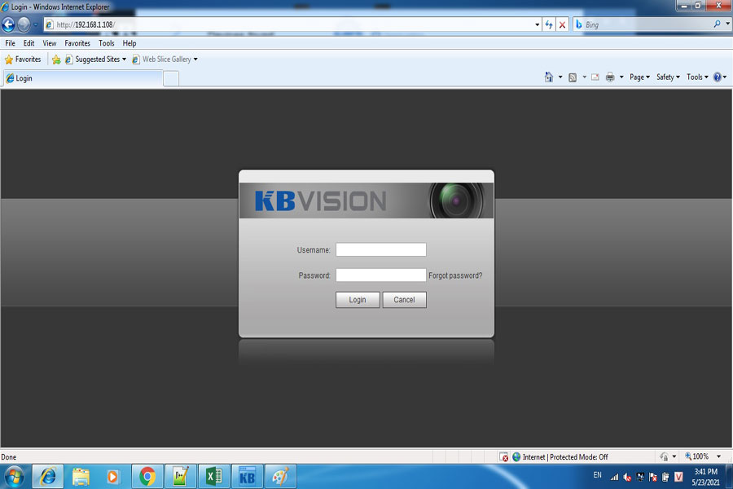

*Figure 54. Camera Login Page*

* Login with username: admin; password: admin123.

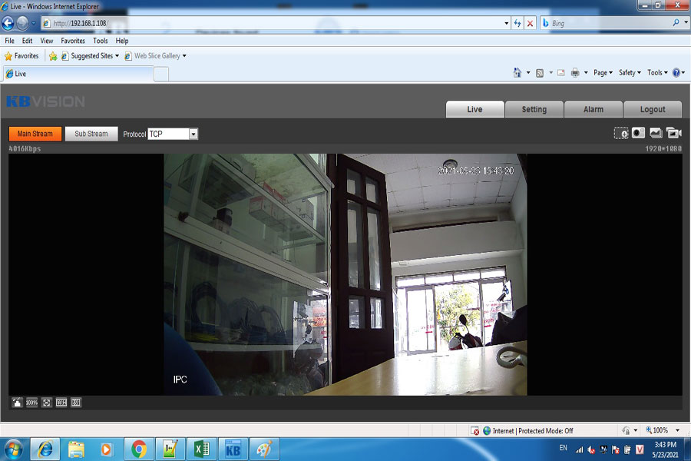

*Figure 55. Camera Home Page*

#### 2.2.2 Install embedded system

* Install barrier system following the below diagram, then the system will automatically connect to WIFI:

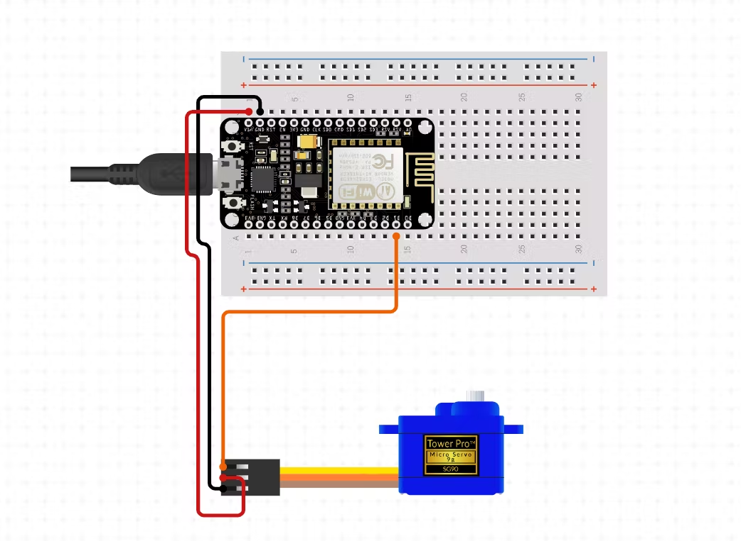

*Figure 56. Barrier system*

* Install the LCD system following the below diagram and plug it into the USB port to control it:

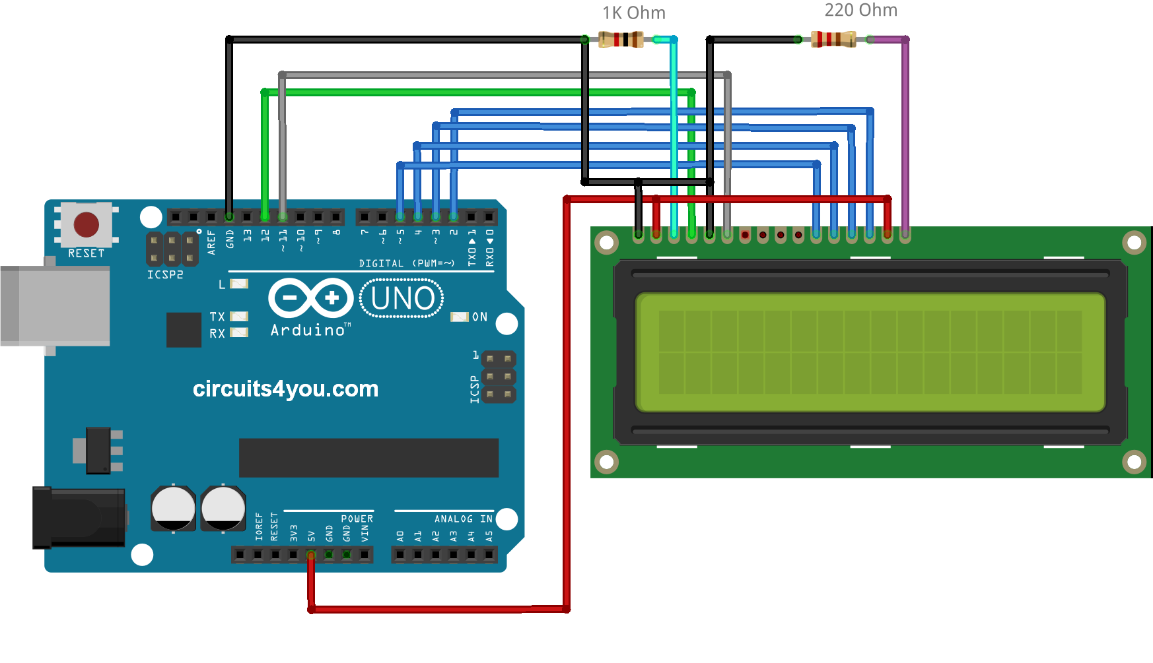

*Figure 57. LCD System*

#### 2.2.3 Install python packages

* You need to have python pre-install to install packages ( If you don’t have python installed, you can follow the instructions in this [link](https://wiki.python.org/moin/BeginnersGuide/Download)).
* Packages need to be installed:
* Torch
* Paddleocr
* Dotenv
* OpenCv
* Threading
* PySimpleGUI
* PIL
* Qrcode
* firebase_admin
* pyrebase
* Open Command Prompt and use this command to install packages:
* pip install <package-name>
* Replace <package-name> with the name of the package from above.

***\*\*Note***: If your computer has a decent GPU and you want to use it to improve the application’s speed then follow these steps:

* Follow instructions from this [link](https://docs.conda.io/projects/conda/en/latest/user-guide/install/windows.html) to install Anaconda
* Download and install CUDA from this [link](https://developer.nvidia.com/cuda-downloads)
* Go to PyTorch website: [PyTorch](https://pytorch.org/get-started/locally/) and choose the version compatible with Anaconda version
* Example:

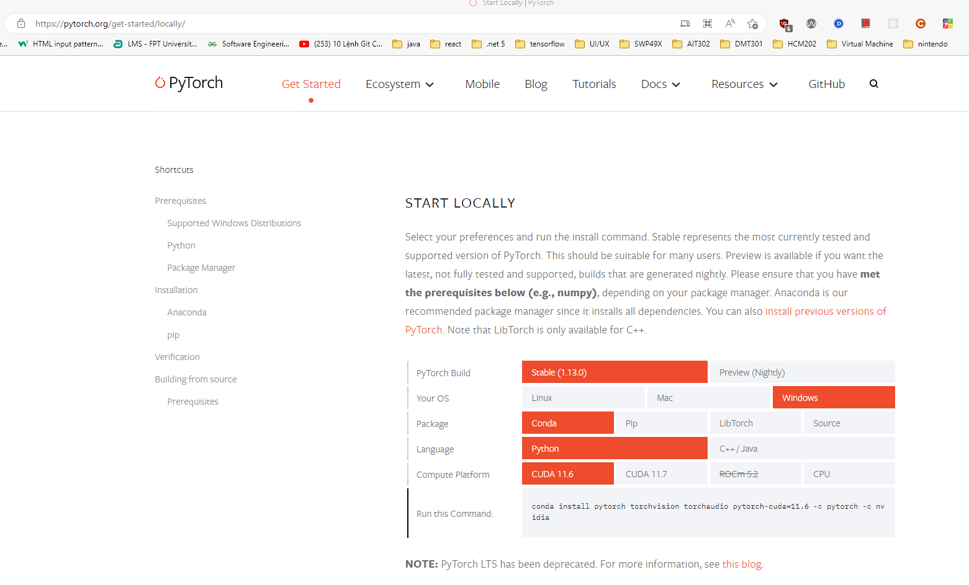

*Figure 58. PyTorch Homepage*

* After choosing the version, open Command Prompt, type in the command from the website, and then run to install the PyTorch package with CUDA support.
* Example command from the figure above

conda install pytorch torchvision torchaudio pytorch-cuda=11.6 -c pytorch -c nvidia

## 3. User Manual

### 3.1 Overview

*Mobile Application:* The application allows user - customer to use their account, use the money they had deposited in the account to find a suitable car park, then book a parking slot, check-in, check-out, and manage their ticket history.

*Web Application:* The application allows users - employees of the APMS system to interact with it and perform various actions based on their role in the system

### 3.2 Booking

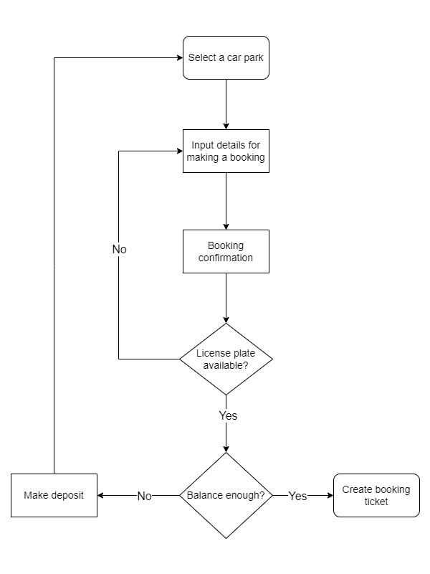

*Figure 59. Booking workflow*

***Description:***

This workflow describes the process of booking a parking slot at the desired car park for users.

***Instructions:***

1. After the user uses their account to login then the user will be redirected to the home page screen (*Figure 8.*), in this screen they see a list of available car parks. Then they can choose one car park from the list and start booking.
2. After a car park is chosen, the user will be redirected to the booking screen (*Figure 9.*). In this screen, the user will be required to enter information to create a booking: license plate number, book date, and book time. When all information is filled in, the user presses on “Go to confirmation page” to confirm their booking.
3. On the booking confirmation screen (*Figure 10* ), the user can see all the information about booking a ticket before our system creates one. When the user is satisfied with all the details of the booking ticket then the user can press “ Pay ”, our system will do final verifications before creating a ticket.
4. First, our system will check for the availability of the license plate. Is there any vehicle with this license plate in any car park? Does this license plate number appear on any booking tickets? If the license plate has none of the above criteria then it is available to create a booking. If one of the criteria appears then our system will respond with an error and require the user to change the booking detail.
5. Second, our system will check the user account’s balance. If the balance is enough to make a booking then our system will subtract the booking fee from the user's balance and create a booking ticket.
   1. If the user's balance is not enough then our system will require the user to deposit by using Paypal and then start over from step 1.

### 3.3 Check-in

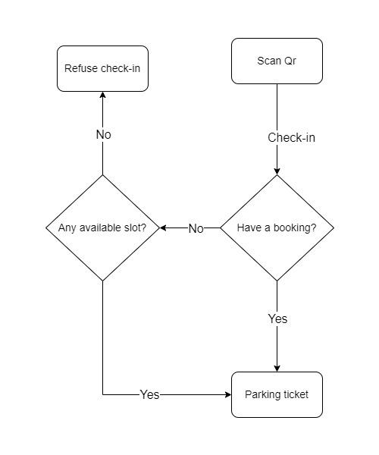

*Figure 60. Check-in workflow*

***Description:***

This workflow describes the process of checking in when users want to go into the car park

***Instructions:***

1. The user can go to the scan QR screen (*Figure 11.*) when they are in the homepage screen (*Figure 8.*) or ticket detail screen (*Figure 13.*) - when the user has booked a slot
2. When the user is checking in, after the mobile application receives data from the QR code then it will prompt a pop-up for the user to double-check if the system is reading the right license plate.
3. After the user confirms that it is the right license plate number, our system will check if the user has booked any slot or slot.
4. If the user has booked a slot, our system will change the booked ticket to a parking ticket then the user can continue to go into the car park and park their car.
   1. If the user has not booked any slot, our system will check for available slots at the current car park.
      1. If there’s no available slot left then the user can’t go in and they have to find a different place to park.
   2. If the car park still has available slots then our system will create a new parking ticket for the user then the user can go in and park their car.

### 3.4 Check-out

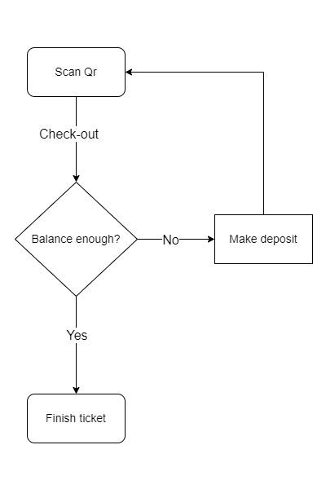

*Figure 61. Check-out workflow*

***Description:***

This workflow describes the process of checking out when users want to leave the car park

***Instructions:***

1. The user can go to the scan QR screen (*Figure 11.*) when they are in the homepage screen (*Figure 8.*) or ticket detail screen (*Figure 15.*)
2. When the user is checking in, after the mobile application receives data from the QR code then it will prompt a pop-up for the user to double-check if the system is reading the right license plate.
3. After the user confirms that it is the correct license plate number, our system will check their account’s balance to see if they can afford the parking fee
   1. If their balance is not enough then the user has to make a deposit and then start over from step 1.
4. If the user has enough money then our system will finish the parking ticket, subtract the parking fee from the account’s balance, and the user can leave the car park.

### 3.5 Manual check-out

*Figure 62. Manual check-out workflow*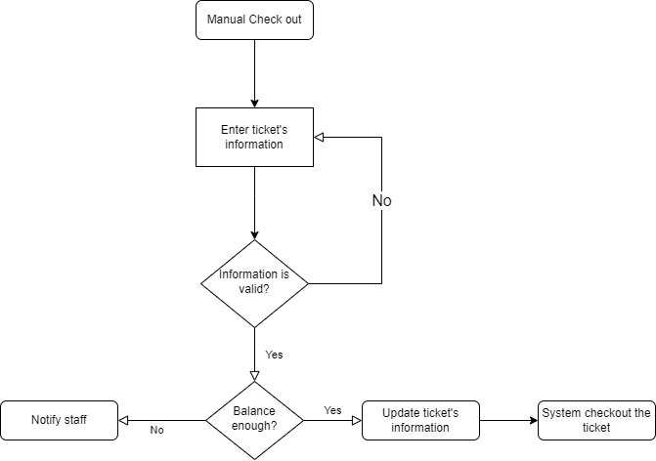

***Description:***

This workflow describes the process of staff manually editing and checking out a ticket because the system was unable to perform this action automatically

***Instructions:***

1. When the system fails to automatically check out the ticket when a customer scans the QR code, it will immediately prompt the staff with the pictures taken by the cameras and the falsely scanned plate number.
2. Staff can then carefully examine the pictures to figure out the correct plate number of the vehicle.
3. The staff will then enter the correct plate number into the text box and send it to the system along with the car park id.
   1. If the system can not find any ticket with the provided plate number, it will throw an error for the staff and they will have to re-enter the plate number again.
4. If the system finds a ticket with the status of “checked-in” and has matched plate number, it will then check for the customer’s account balance, if the balance is enough to pay for the ticket’s fee, the system will then perform a check out operation for the ticket and user can leave the car park.
   1. If the customer’s account balance is not sufficient, the system will notify the staff for further action.

### 3.5 Update car park information

*Figure 63. Update car park information workflow*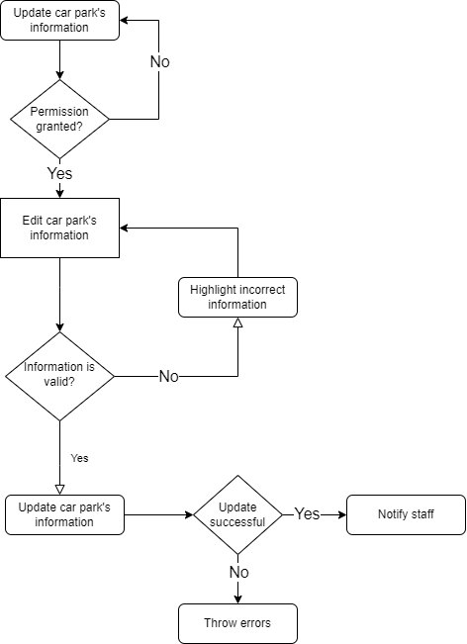

***Description:***

This workflow describes how an employee can change the car park’s information in case the existing information is incorrect or need to be updated to match the current properties of the car park

***Instructions:***

1. From the dashboard, the employee can access the update page through clicking the Car Park List (for admin) or My Park (for owner and staff) from the sidebar.
2. User can then edit the information about the car park.
   1. If the user is a staff, they must have permission from the owner of the car park to perform the mentioned action.
3. After finishing editing the car park’s information, the user can submit the information for validation.
4. If all information is valid, the system will then send a request to update the car park to the server.
   1. If there is any validation error that occurs, the system will notify the user about the invalid details and it is required to update that property until it is valid to update the car park’s information
5. The server will then perform the update action and notify the user about the result
   1. If the update is successful, the system will notify with a toast message and the car park’s details will be fetched again to reflect the changes.
   2. If the update is unsuccessful, the system will notify the user with a toast message containing the reason why it can not perform that action.

### 3.6 Create a new employee’s account

*Figure 64. Create a new employee’s account workflow*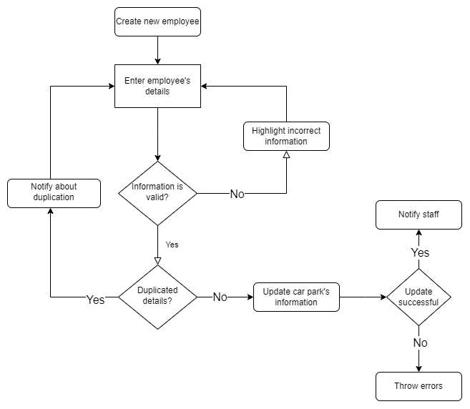

***Description:***

This workflow describes the process of creating a new employee account (of role Admin, Owner, or Staff)

***Instructions:***

1. From the dashboard, the admin can navigate to the employee list through the sidebar panel, afterward, clicking the “Add Employee” button will prompt the admin with the create form.
2. Admin will then fill in the new employee’s detail and submit them for validation
3. If all information is valid, the system will make a request to the server for creating a new employee
   1. If there is any invalidation, the system will highlight the invalid details and it is required to correct them to continue the process.
4. The server will then check in the database for any duplication with provided information from the user.
   1. If there is any duplication (which means that the information the user supplied has been used) the server will throw an error back to the user and the process will have to roll back to step 2.
5. After all validation has been completed, the system will then attempt to create a new account and insert it to the database.
   1. If the creation is successful, the system will notify with a toast message and the employee list will be fetched again to reflect the changes.
   2. If the creation is unsuccessful, the system will notify the user with a toast message containing the reason why it can not perform that action.